University of Seville  
 School of Computer Engineering

**Performance Report**



Software engineering  
Design and testing 2

2018 – 2019

06/04/2019

Group 26

**Index**

1. Observations 4

2. Package 4

Create 4

Edit 5

Delete 7

Conclusion 9

3. Evaluation 10

Create 10

Delete 11

Conclusion 13

4. Message 13

Send 13

Move 15

Copy 17

Delete 19

Conclusion 21

5. Message box 21

Create 21

Edit 23

Delete 25

Conclusion 27

6. Social profile 27

Create 27

Edit 29

Delete 31

Conclusion 33

7. Dashboard 34

Show dashboard and launch all process 34

Conclusion 36

8. Category 36

Create 36

Edit 38

Delete 39

Conclusion 41

9. Request 42

Create 42

Edit 43

Delete 45

Conclusion 46

10. TraverseTown 47

Create 47

Edit 48

Delete 50

Conclusion 52

11. Issue 53

Create 53

Delete 54

Conclusion 56

12. Town 56

Create 56

Edit 58

Delete 60

Conclusion 61

13. Comment 62

Create 62

Conclusion 63

14. Configuration 64

Display and edit 64

Conclusion 65

15. Finder 66

Search 66

Conclusion 67

16. Offer 68

Create/Edit 68

Delete 69

Conclusion 71

17. Curricula 72

Create a curriculum 72

Edit a curriculum 73

Delete a curriculum 75

Conclusion 76

18. Records (Professional and Miscellaneous record) 76

Create Miscellaneous Record 76

Create Professional Record 78

Edit a Miscellaneous Record 80

Edit a Professional Record 81

Delete a professional record 83

Delete a miscellaneous data 84

Conclusion 86

19. Actor 86

Create 86

Edit 87

Delete 89

Conclusion 90

20. Vehicle 90

Create 90

Edit 92

Delete 93

Conclusion 95

21. Solicitation 95

Create 95

Edit 97

Delete 98

Conclusion 100

22. Sponsorship 100

Create 100

Edit 102

Delete 103

Conclusion 105

23. Fare 105

Create 105

Edit 106

Delete 108

Conclusion 109

24. Conclusion of the performance 110

# Observations

We have considered that our performance tests were valid as long as they were lasting between 2’5 and 3 seconds and no error was showed.

# Package

## Create

Sequence:

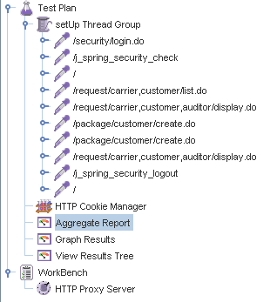

Aggregate Report:

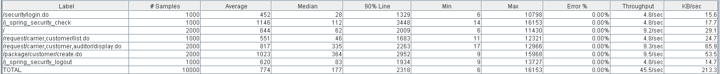



Thread properties:

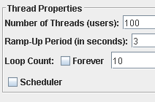

Graph Results:

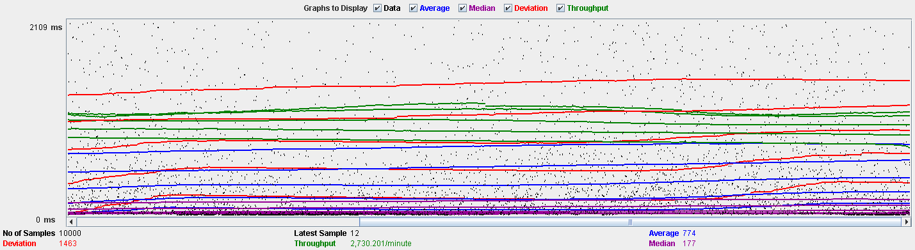

Performance Results:

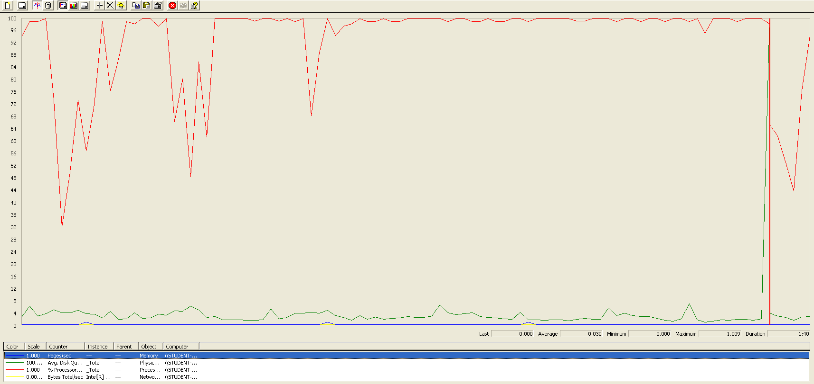

The CPU is always being used while the disk usage is barely noticeable..

## Edit

Sequence:

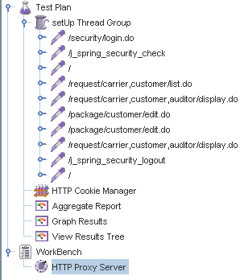

Aggregate Report:

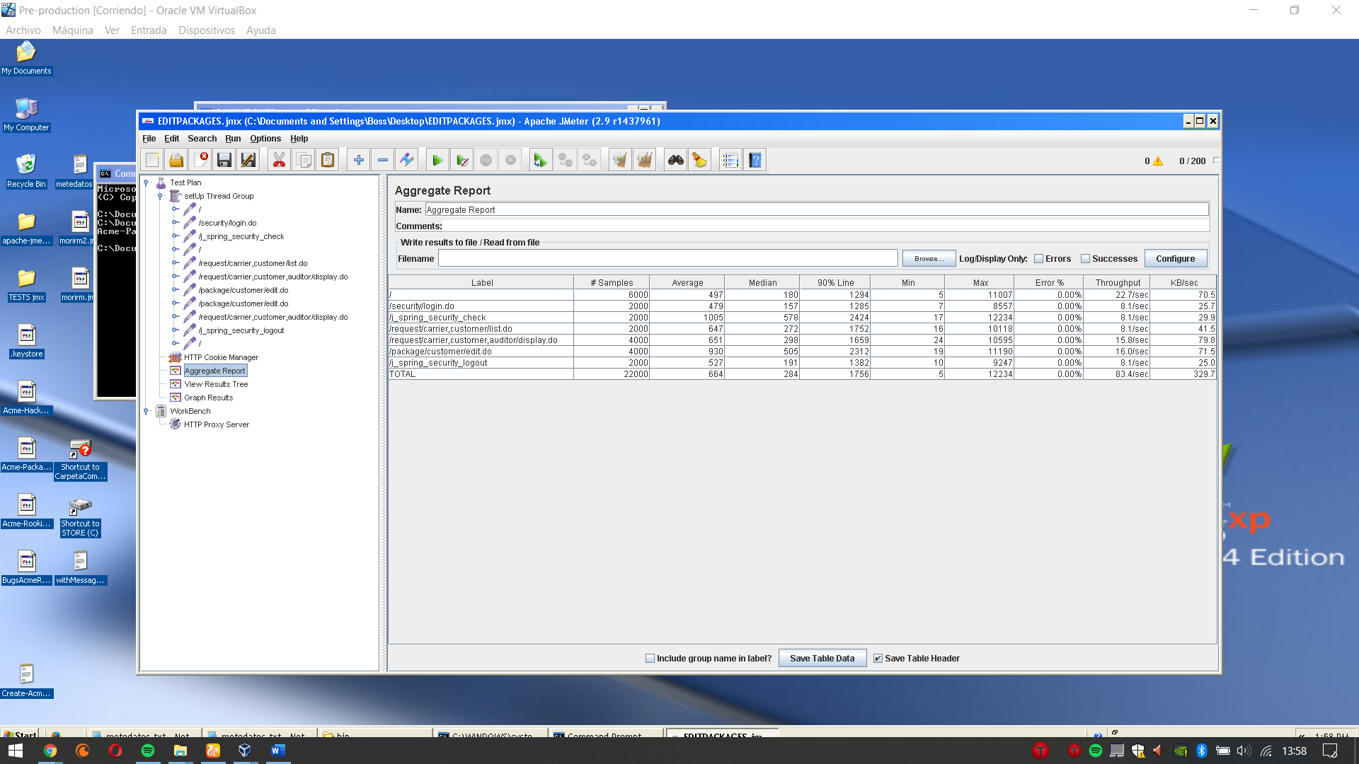

Thread properties:

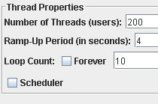

Graph Results:

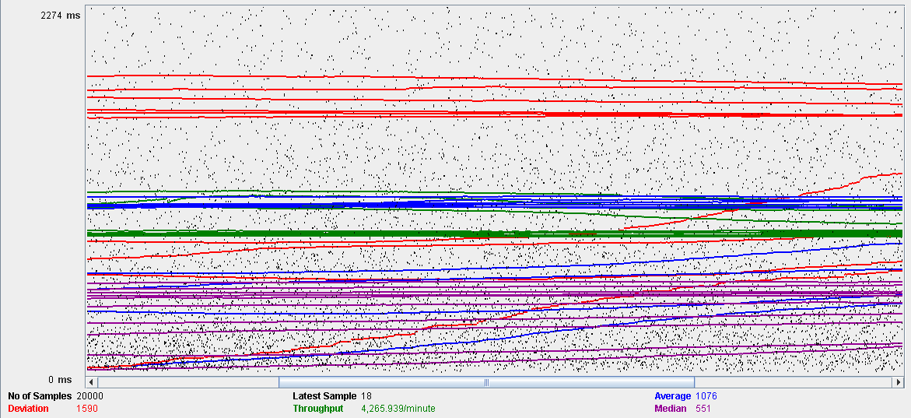

Performance Results:

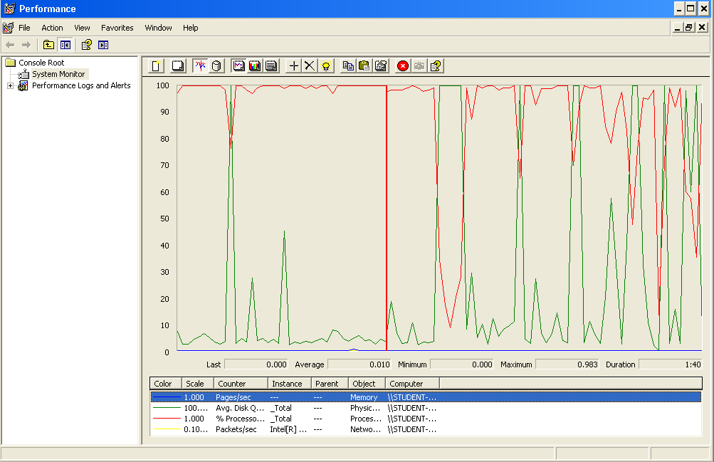

Again we can see that the CPU is always being used while the disk usage shows some periodic peaks.

## Delete

Sequence:

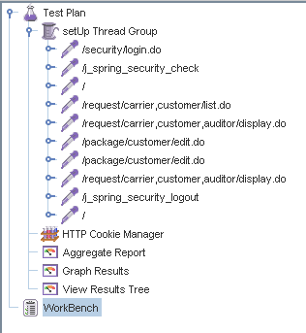

Aggregate Report:

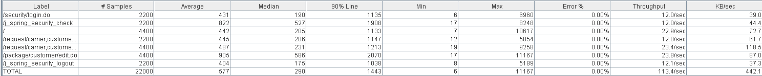



Thread properties:

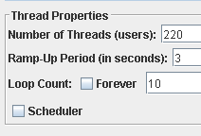.

Graph Results:

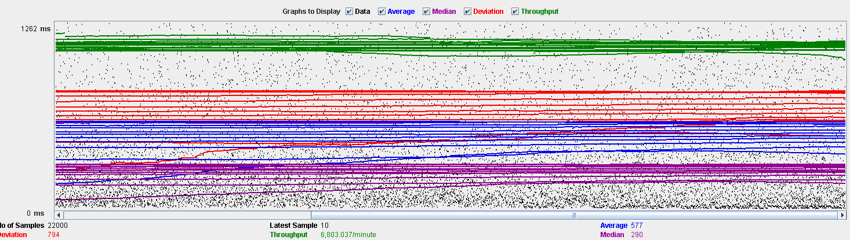

Performance Results:

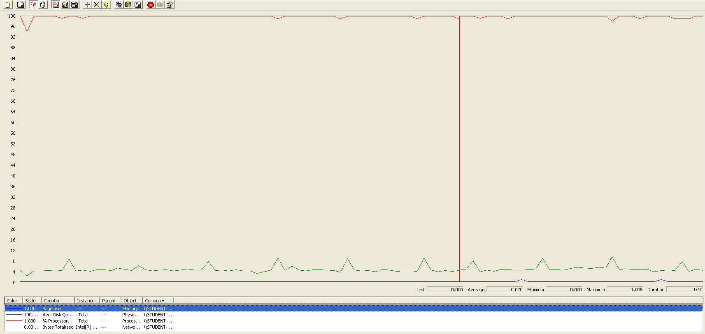

Again we can see that the CPU is always being used while the disk usage shows some peaks. The times are a little bit lower in order to avoid errors.

## Conclusion

The test was performed using:

CPU: i7 6700hq (2 cores in the virtual machine)

RAM: 4 GB (virtual machine)

For this use case we can say that the limitation occurs during the creation process, being the maximum of concurrent users 100. The times during the delete process did not reach the 3 seconds mark in order to avoid errors.

# Evaluation

## Create

Sequence:

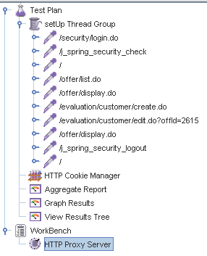

Aggregate Report:

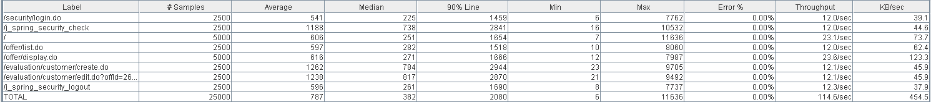



Thread properties:

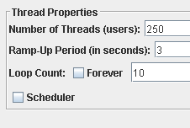

Graph Results:

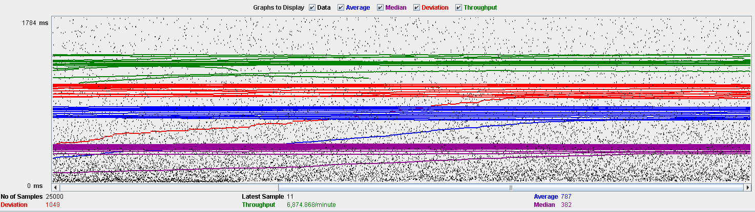

Performance Results:

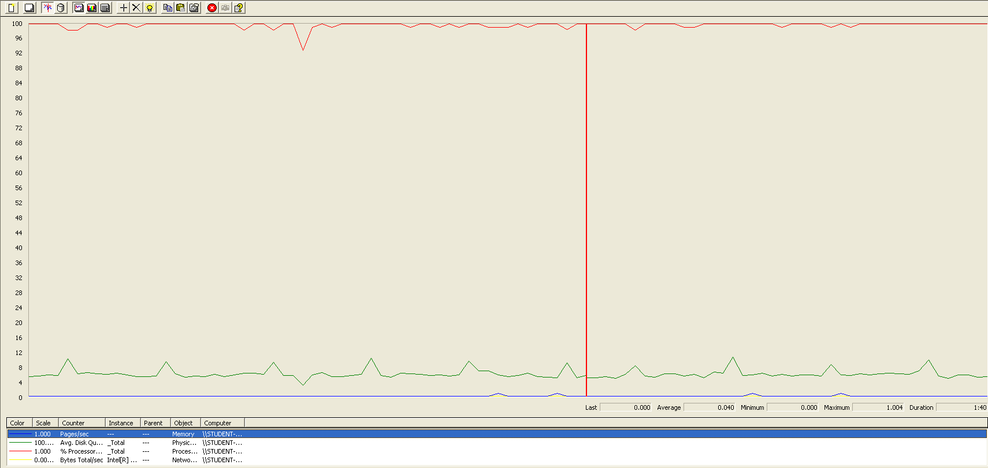

The CPU is always being used while the disk usage is barely noticeable.

## Delete

Sequence:

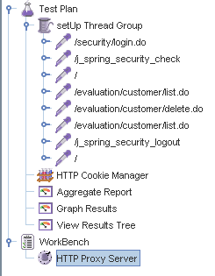

Aggregate Report:





Thread properties:

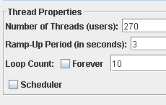

Graph Results:

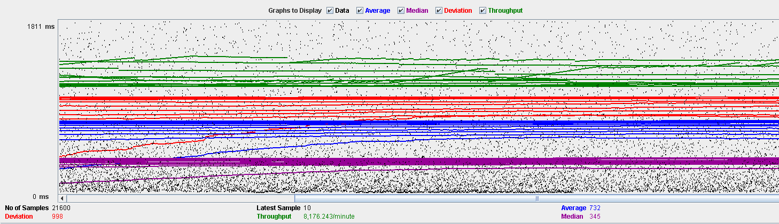

Performance Results:

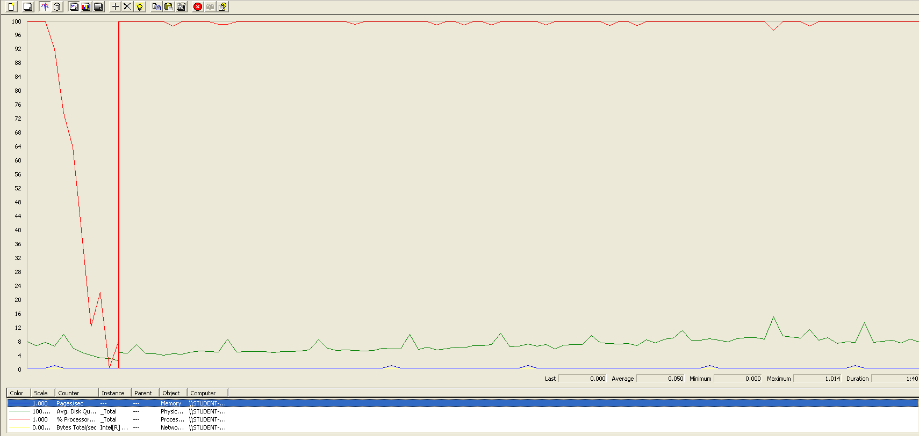

The CPU is always being used while the disk usage is barely noticeable.

## Conclusion

The test was performed using:

CPU: i7 7700hq (2 cores in the virtual machine)

RAM: 4 GB (virtual machine)

For this use case we can say that the limitation occurs during the creation process, being the maximum of concurrent users 250.

# Message

## Send

Sequence:

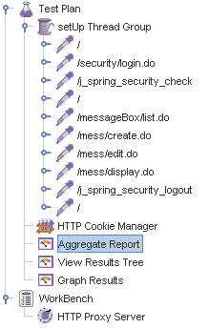

Aggregate Report:

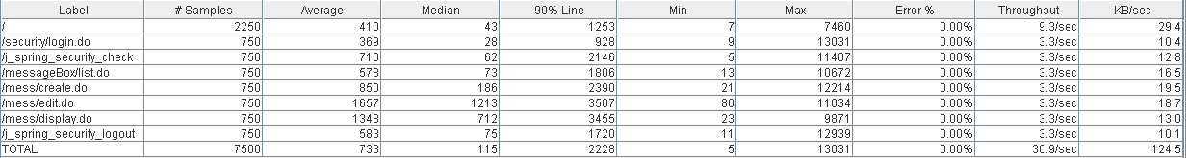

Thread properties:

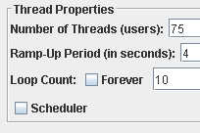

Graph Results:

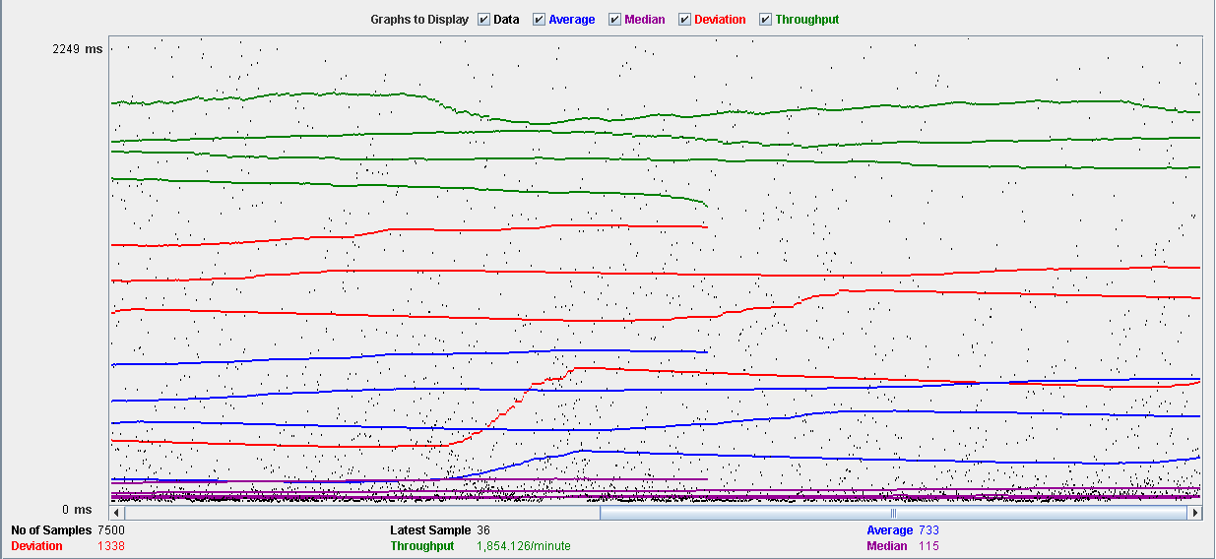

Performance Results:

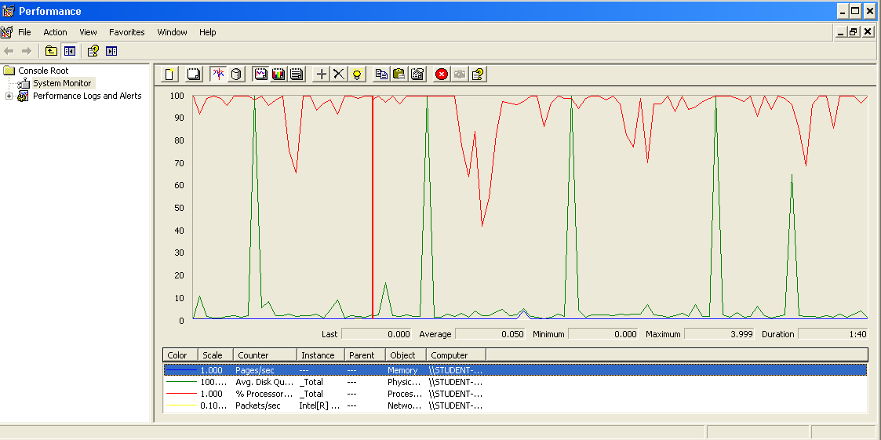

The CPU is always being used and some picks of physical disk.

## Move

Sequence:

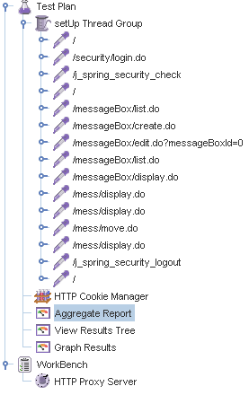

Aggregate Report: 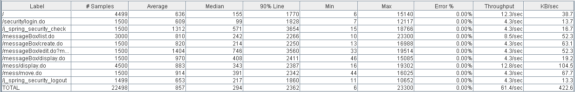



Thread properties:

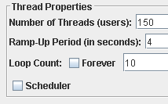

Graph Results:

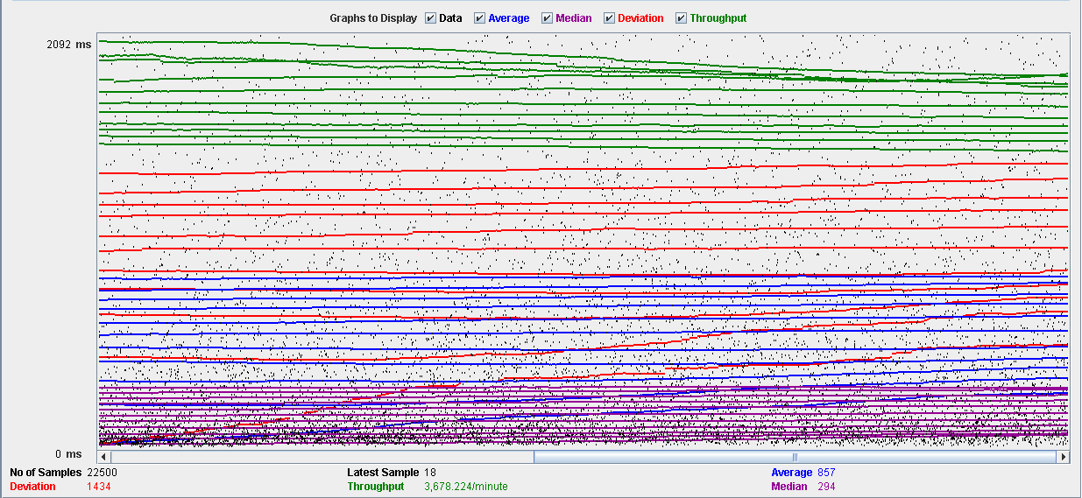

Performance Results:

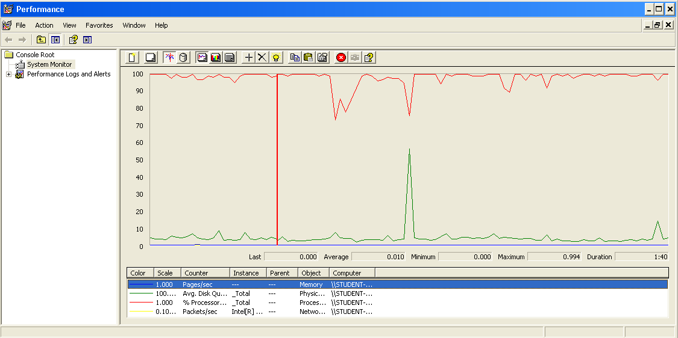

The CPU is always being used and some picks of physical disk.

## Copy

Sequence:

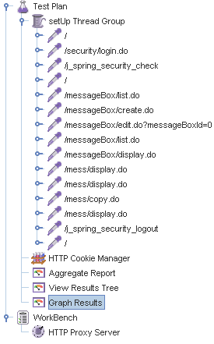

Aggregate Report: 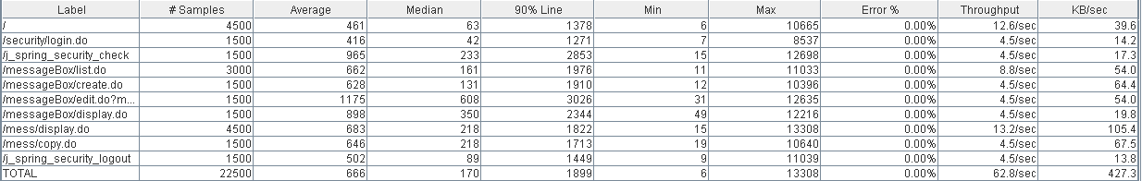



Thread properties:



Graph Results:

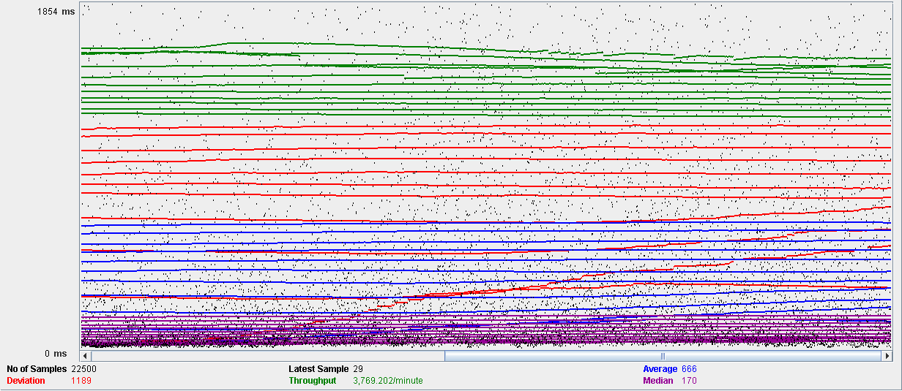

Performance Results:

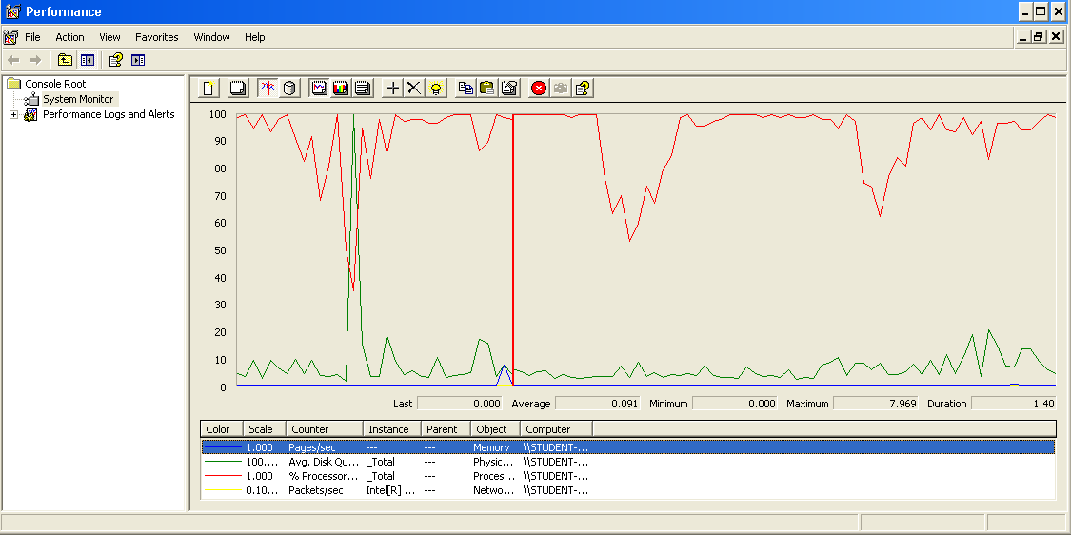

The CPU is always being used and a pick of physical disk.

## Delete

Sequence:

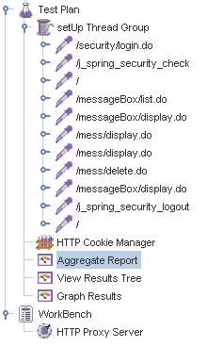

Aggregate Report: 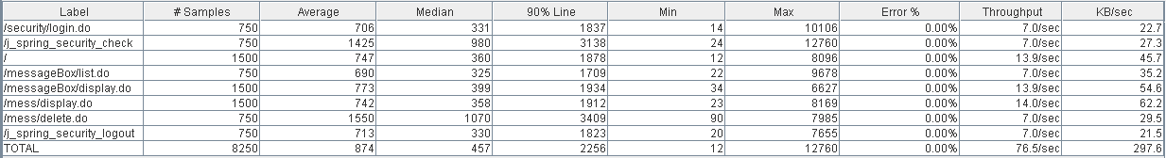



Thread properties:



Graph Results:

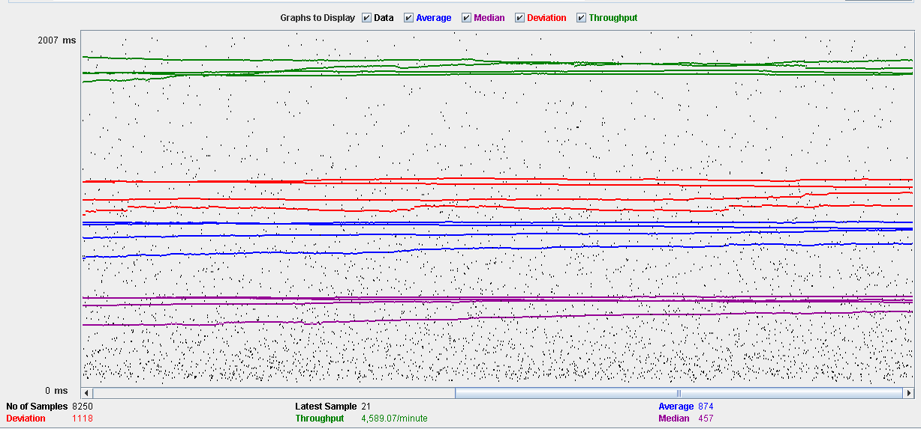

Performance Results:

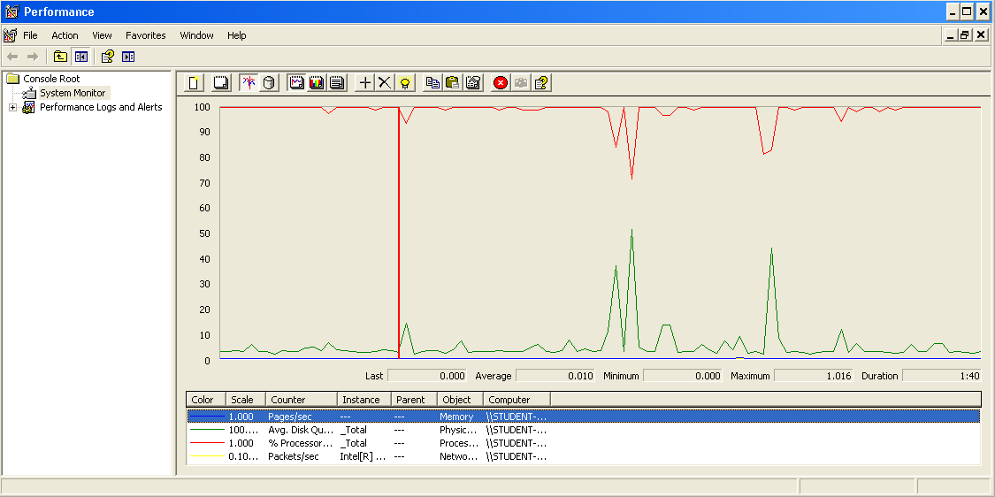

The CPU is always being used while the physical disk has some picks.

## Conclusion

The test was performed using:

CPU: i7 7700hq (2 cores in the virtual machine)

RAM: 2 GB (virtual machine)

For this use case we can say that the limitation occurs during the send and delete process, being the maximum of concurrent users 75.

# Message box

## Create

Sequence:

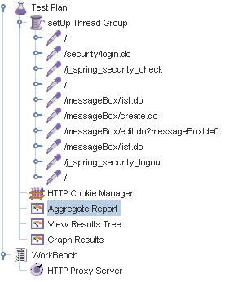

Aggregate Report:

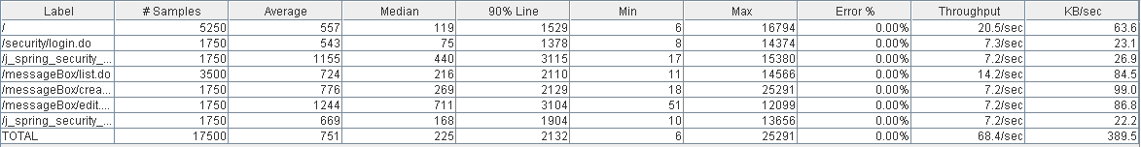

Thread properties:

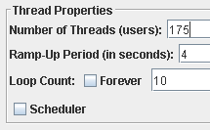

Graph Results:

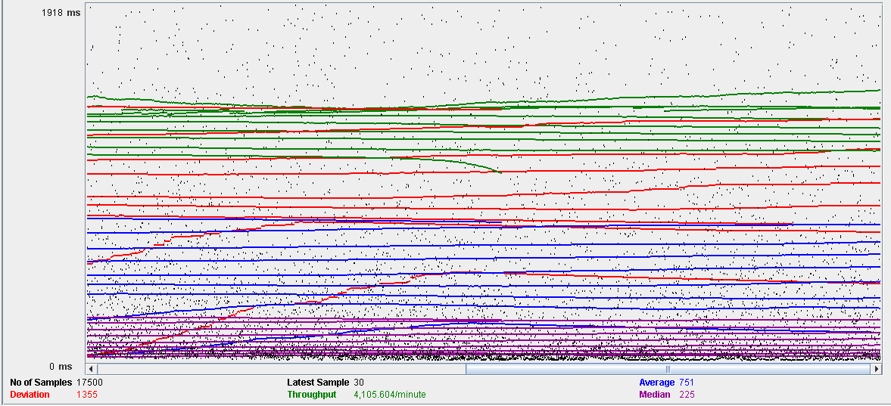

Performance Results:

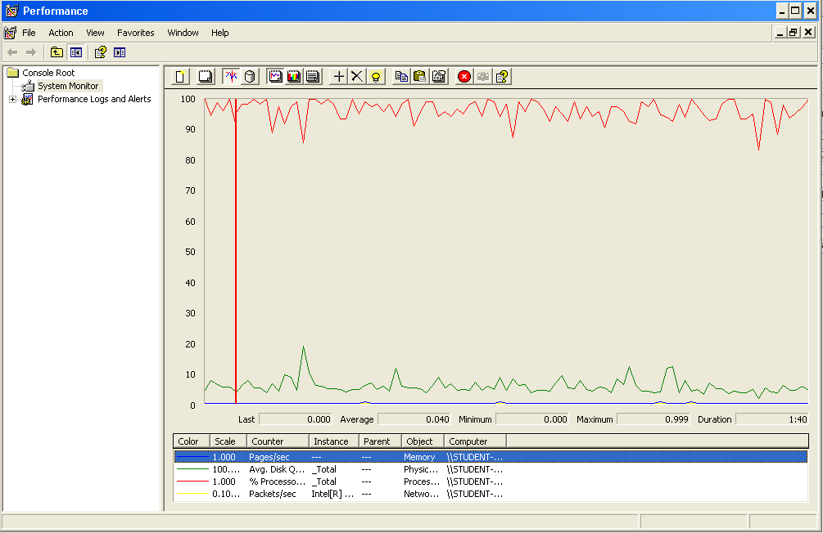

The CPU is always being used and physical disk usage is barely noticeable.

## Edit

Sequence:

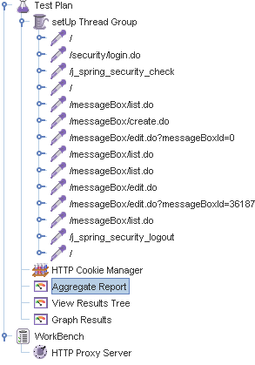

Aggregate Report: 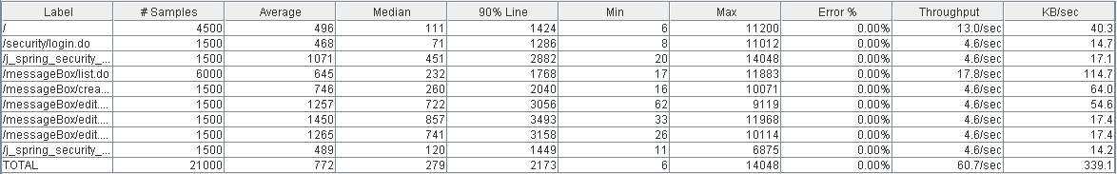



Thread properties:



Graph Results:

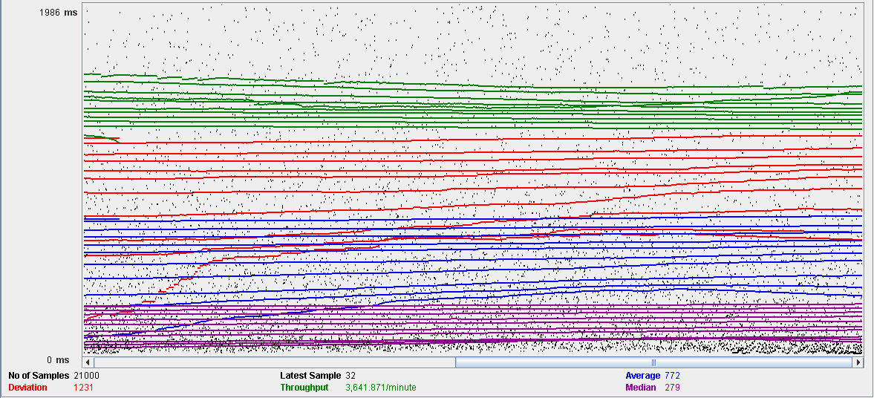

Performance Results:

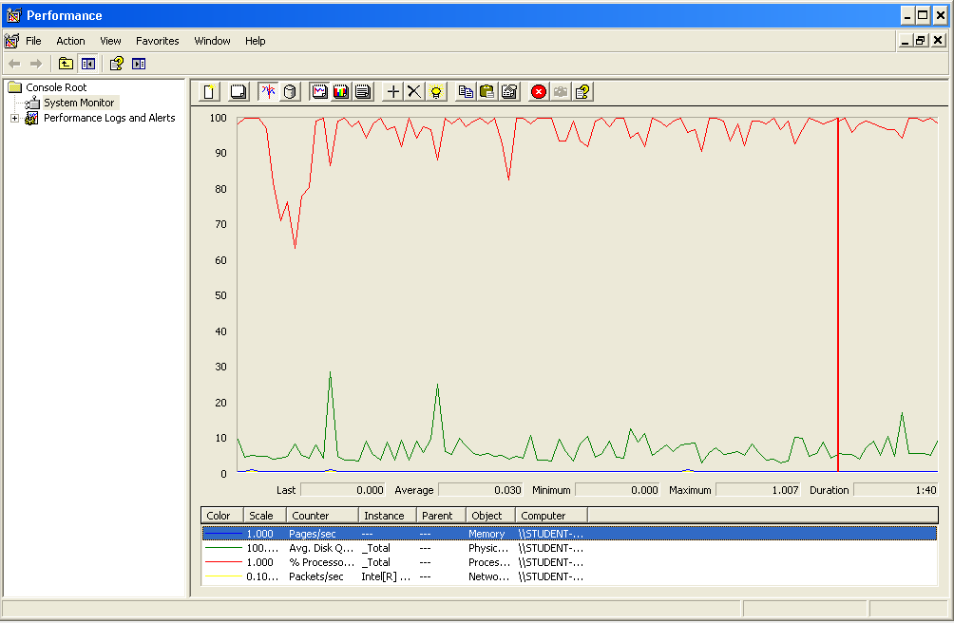

The CPU is always being used and small picks of physical disk

## Delete

Sequence:

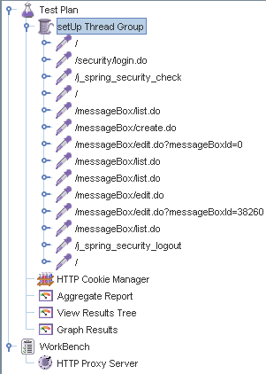

Aggregate Report: 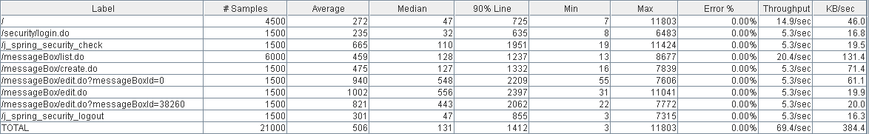



Thread properties:



Graph Results:

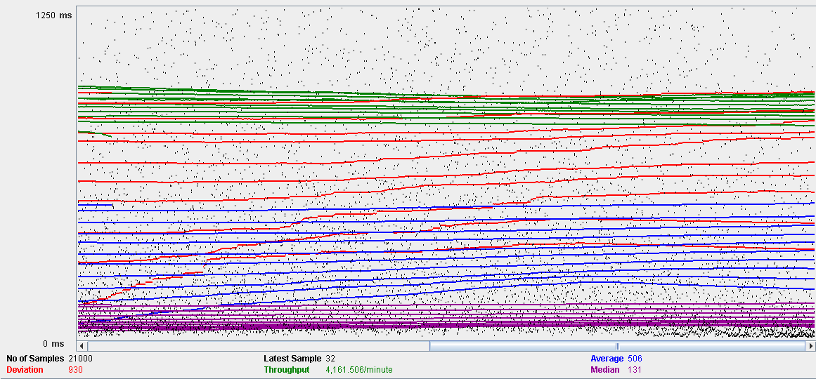

Performance Results:

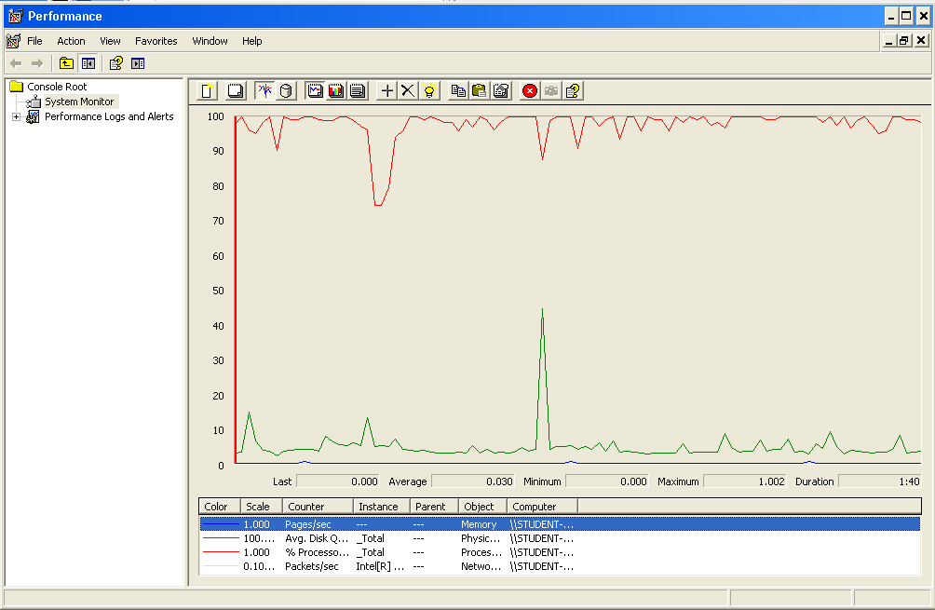

The CPU is always being used while the memory has some picks.

## Conclusion

The test was performed using:

CPU: i7 7700hq (2 cores in the virtual machine)

RAM: 2 GB (virtual machine)

For this use case we can say that the limitation occurs during the edition process, being the maximum of concurrent users 150.

# Social profile

## Create

Sequence:

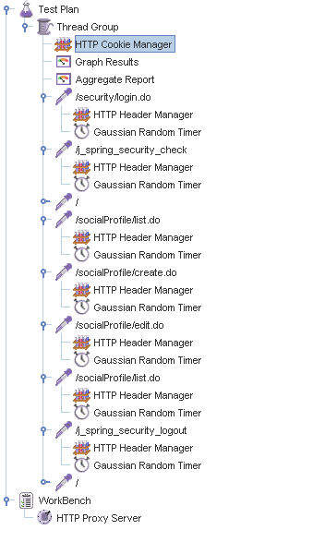

Aggregate Report:

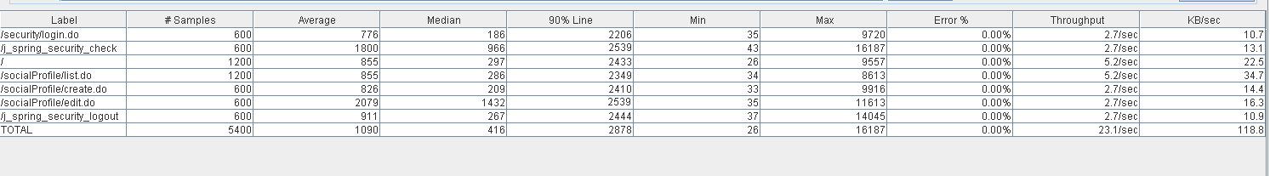

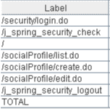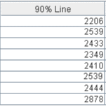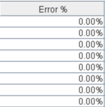

Thread properties:

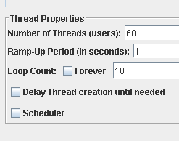

Graph Results:

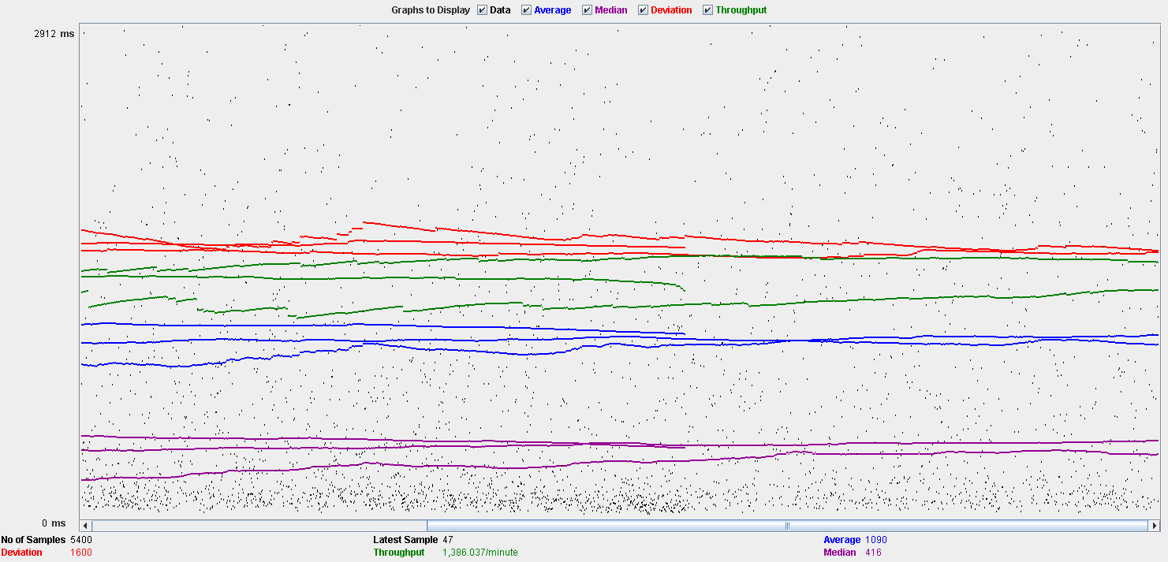

Performance Results:

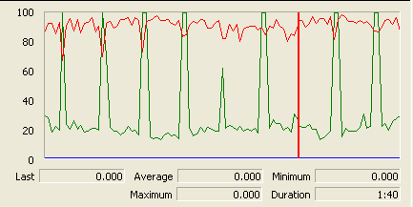

The CPU is always being used while the disk show many peaks.

## Edit

Sequence:

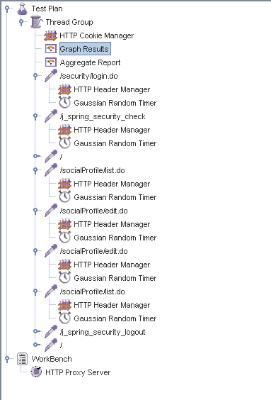

Aggregate Report:

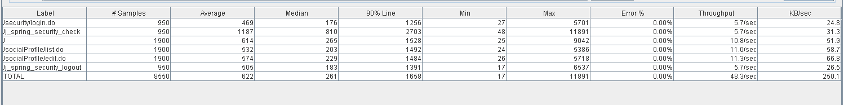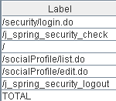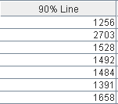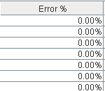

Thread properties:

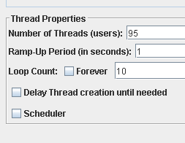

Graph Results:

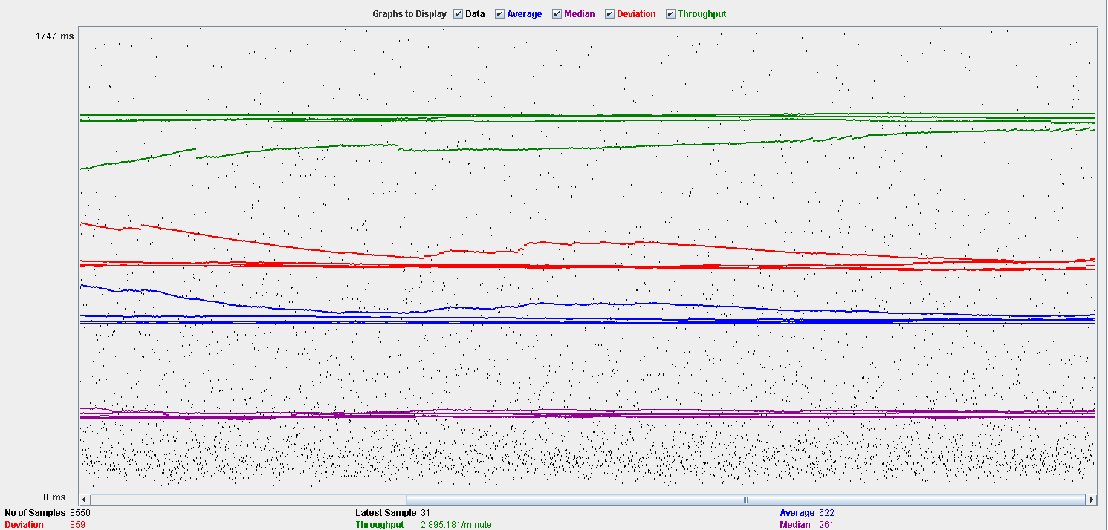

Performance Results:

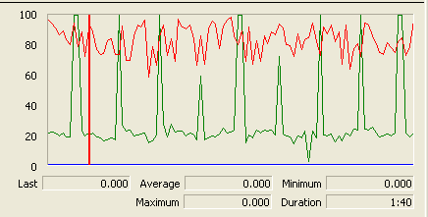

Again we can see that the CPU is always being used while the disk usage shows some periodic peaks.

## Delete

Sequence:

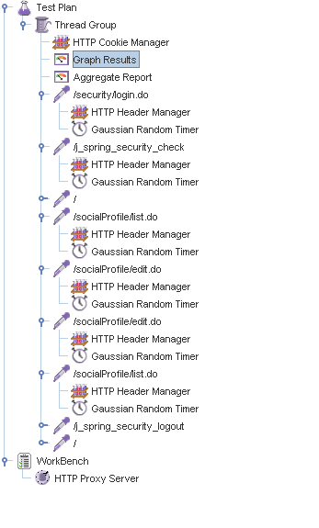

Aggregate Report:

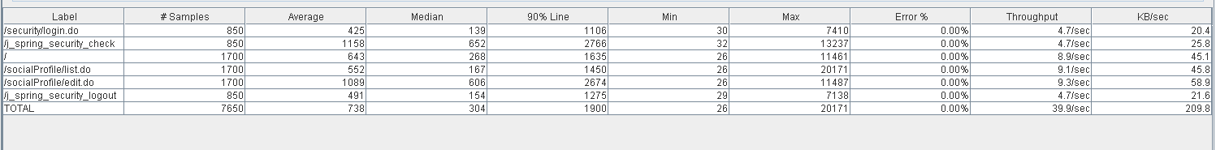

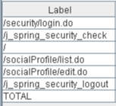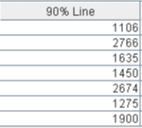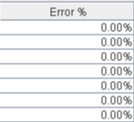

Thread properties:

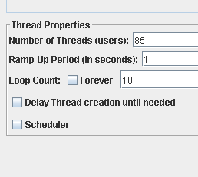.

Graph Results:

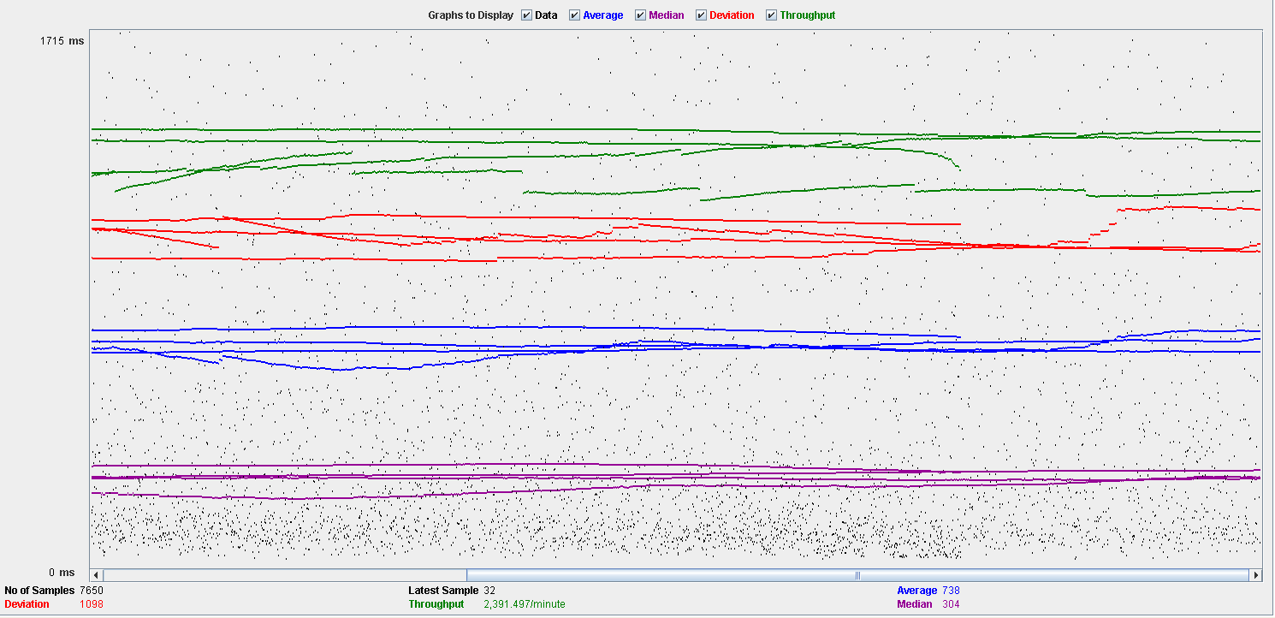

Performance Results:

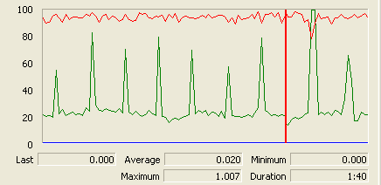

Again we can see that the CPU is always being used while the disk usage shows some peaks.

## Conclusion

The test was performed using:

CPU: i5 2500k (2 cores in the virtual machine)

RAM: 2 GB (virtual machine)

For this use case we can say that the limitation occurs during the creation process, being the maximum of concurrent users 60.

# Dashboard

## Show dashboard and launch all process

Sequence:

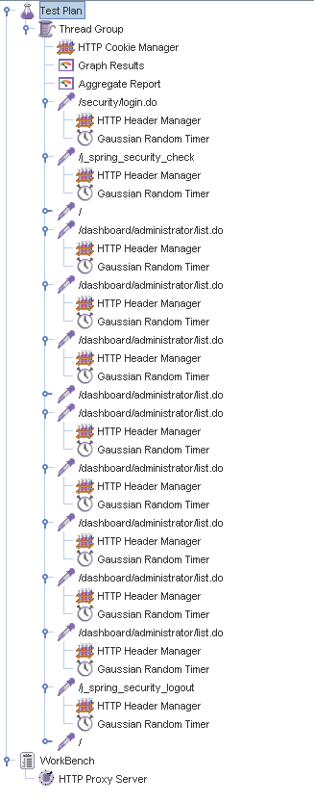

Aggregate Report:

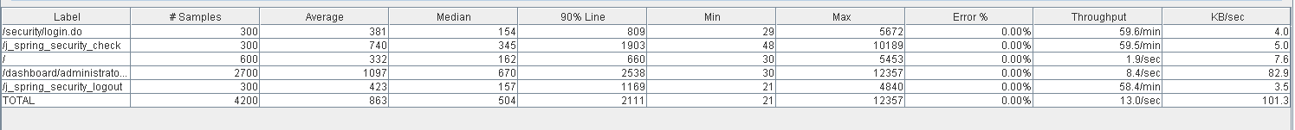

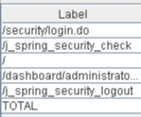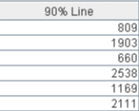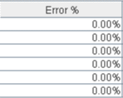

Thread properties:

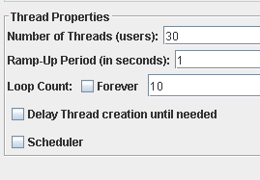

Graph Results:

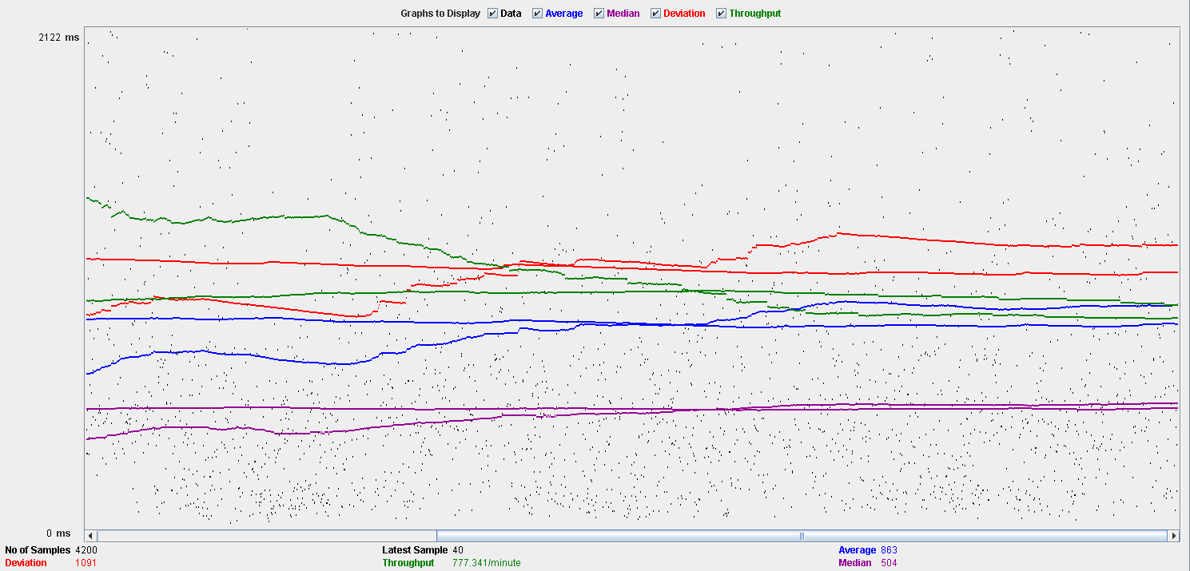

Performance Results:

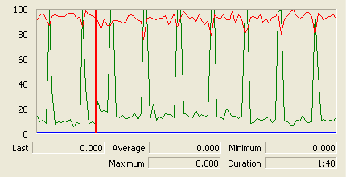

The CPU is always being used while the disk show some peaks.

## Conclusion

The test was performed using:

CPU: i5 2500k (2 cores in the virtual machine)

RAM: 2 GB (virtual machine)

For this use case we can say that the limitation around 30 users.

# Category

## Create

Sequence:

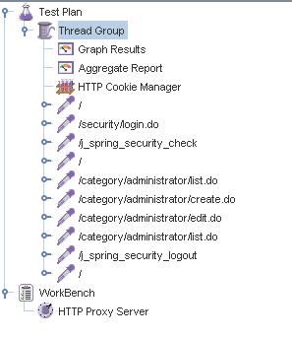

Aggregate Report:

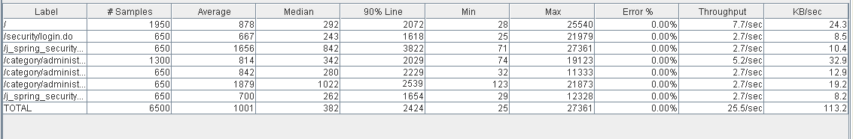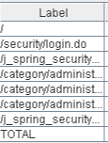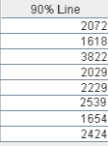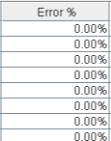

Thread properties:

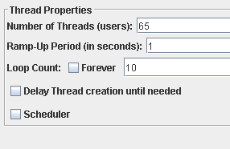

Graph Results:

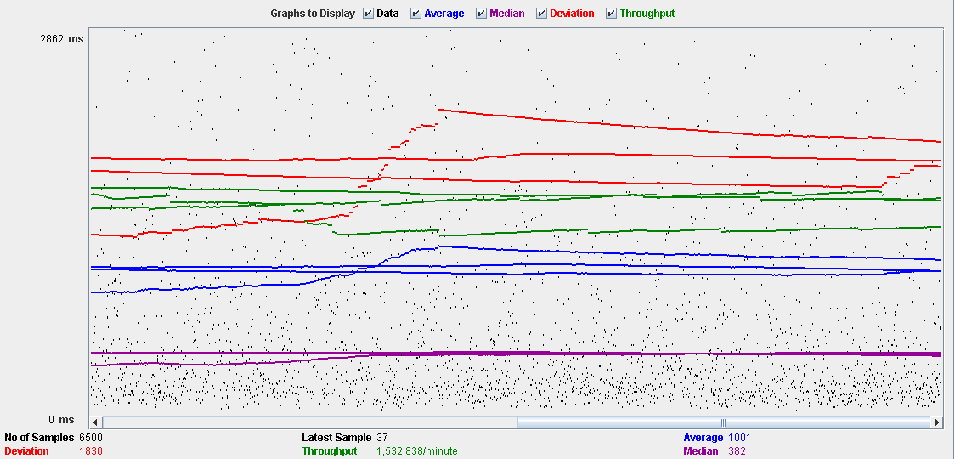

Performance Results:

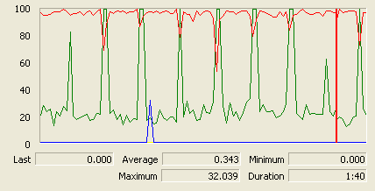

The CPU is always being used and disk show some peaks.

## Edit

Sequence:

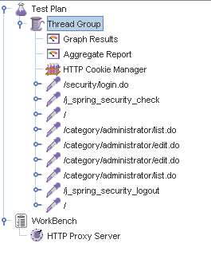

Aggregate Report:

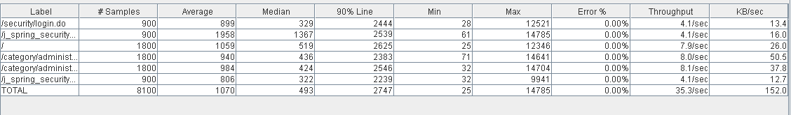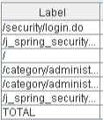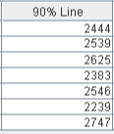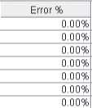

Thread properties:

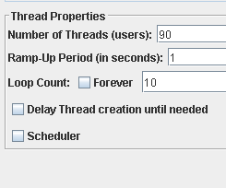

Graph Results:

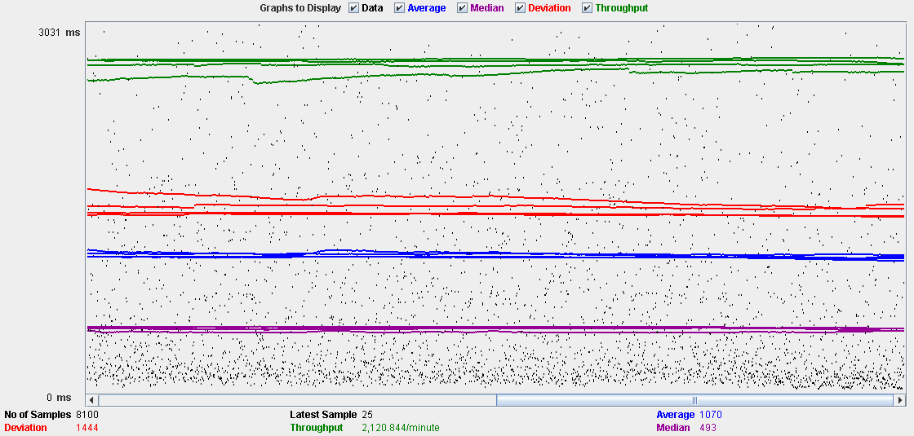

Performance Results:

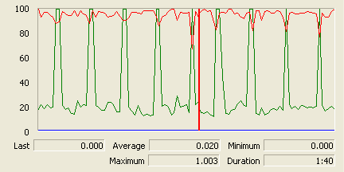

The CPU is always being used and the disk show som peaks.

## Delete

Sequence:

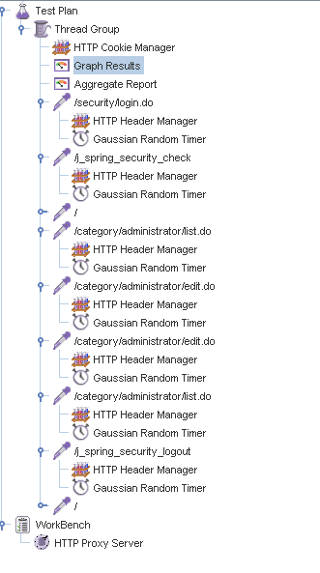

Aggregate Report:

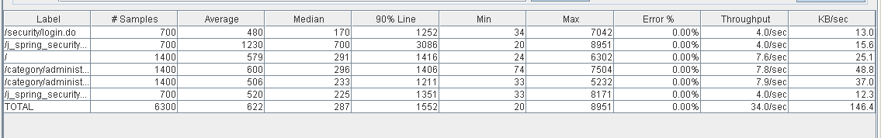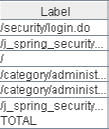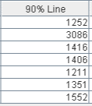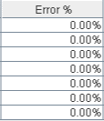

Thread properties:

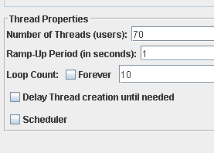

Graph Results:

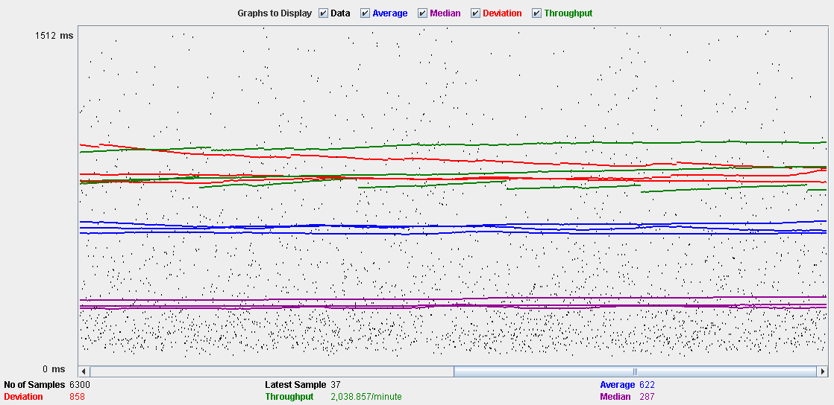

Performance Results:

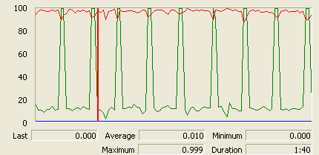

The CPU is always being used and disk show some peaks.

## Conclusion

The test was performed using:

CPU: i5 2500k (2 cores in the virtual machine)

RAM: 2 GB (virtual machine)

For this use case we can say that the limitation occurs during the create process, being the maximum of concurrent users 65.

# Request

## Create

Sequence:

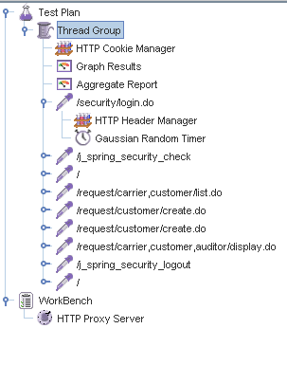

Aggregate Report:

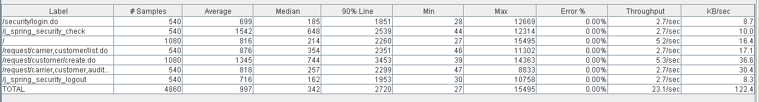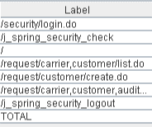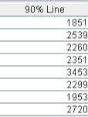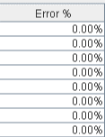

Thread properties:

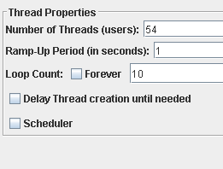

Graph Results:

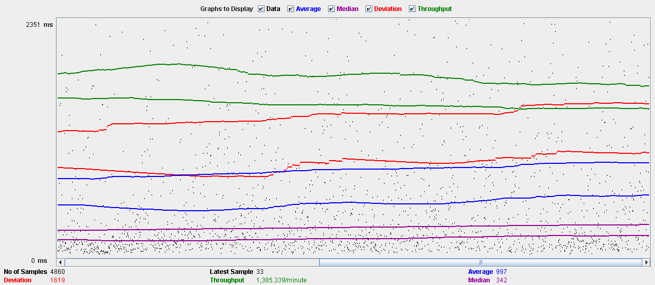

Performance Results:

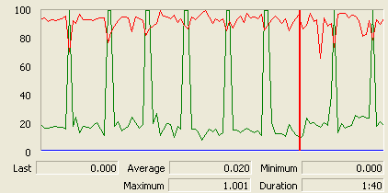

The CPU is always being used and physical disk show some peaks.

## Edit

Sequence:

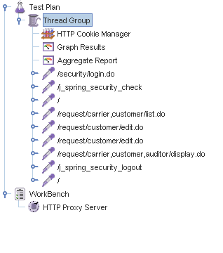

Aggregate Report:

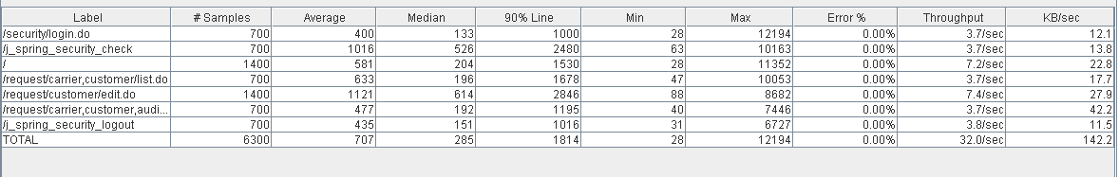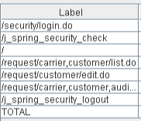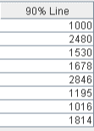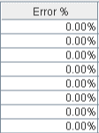

Thread properties:

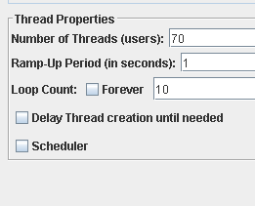

Graph Results:

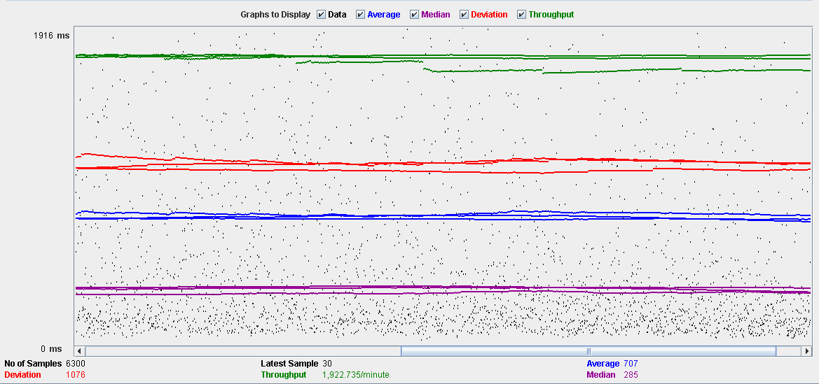

Performance Results:

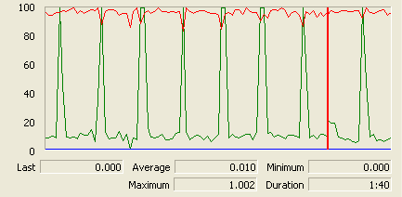

The CPU is always being used and disk show some peaks.

## Delete

Sequence:

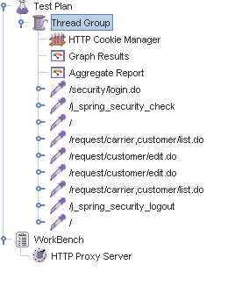

Aggregate Report:

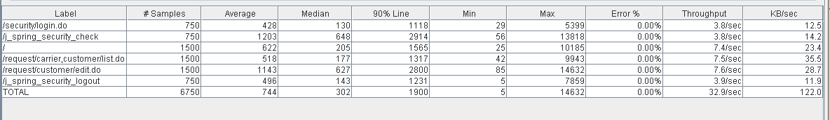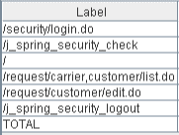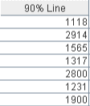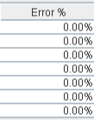

Thread properties:

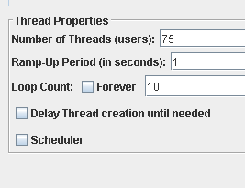

Graph Results:

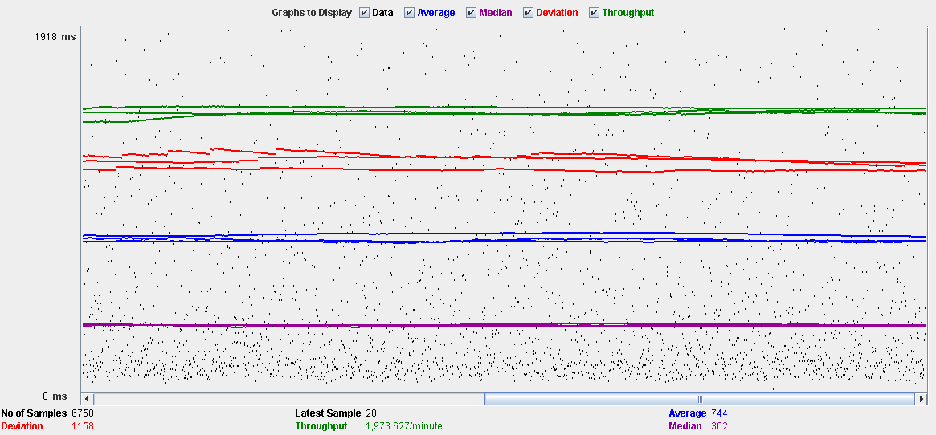

Performance Results:

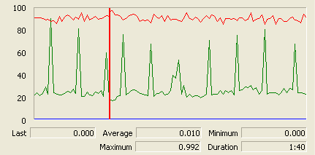

The CPU is always being used while the memory has some peaks.

## Conclusion

The test was performed using:

CPU: i5 2500kk (2 cores in the virtual machine)

RAM: 2 GB (virtual machine)

For this use case we can say that the limitation occurs during the creation process, being the maximum of concurrent users 54.

# TraverseTown

## Create

Sequence:

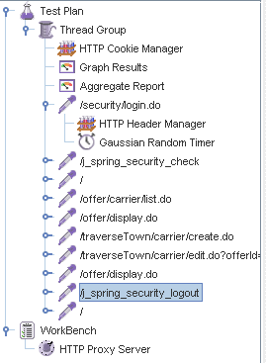

Aggregate Report:

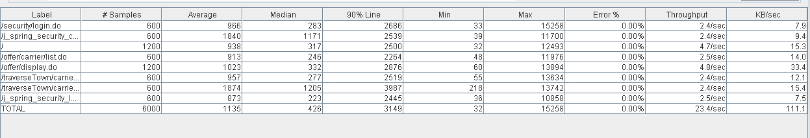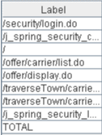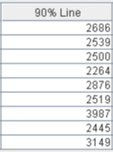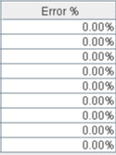

Thread properties:

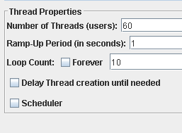

Graph Results:

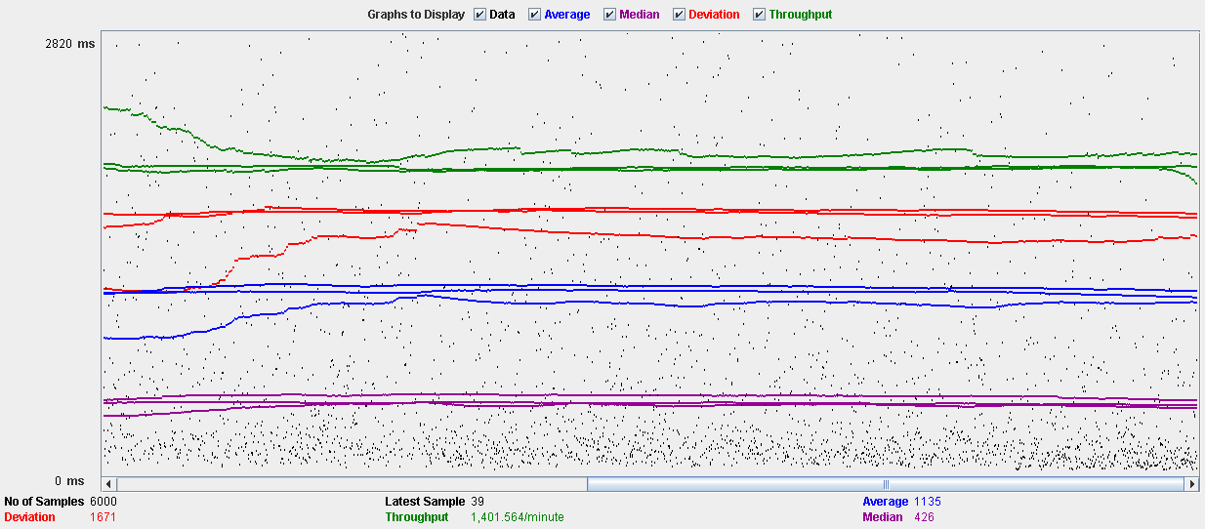

Performance Results:

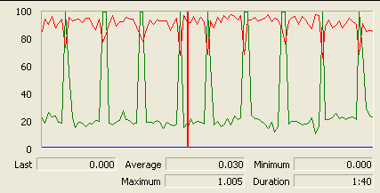

The CPU is always being used and physical disk show some peaks.

## Edit

Sequence:

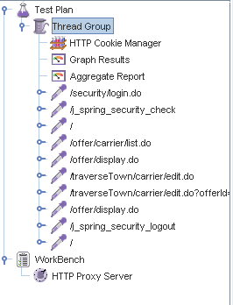

Aggregate Report:

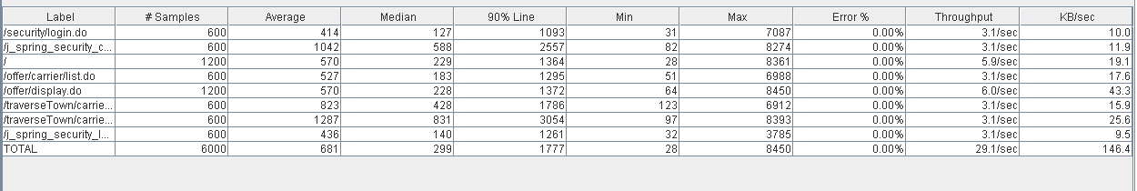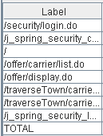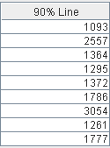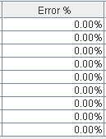

Thread properties:

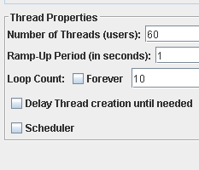

Graph Results:

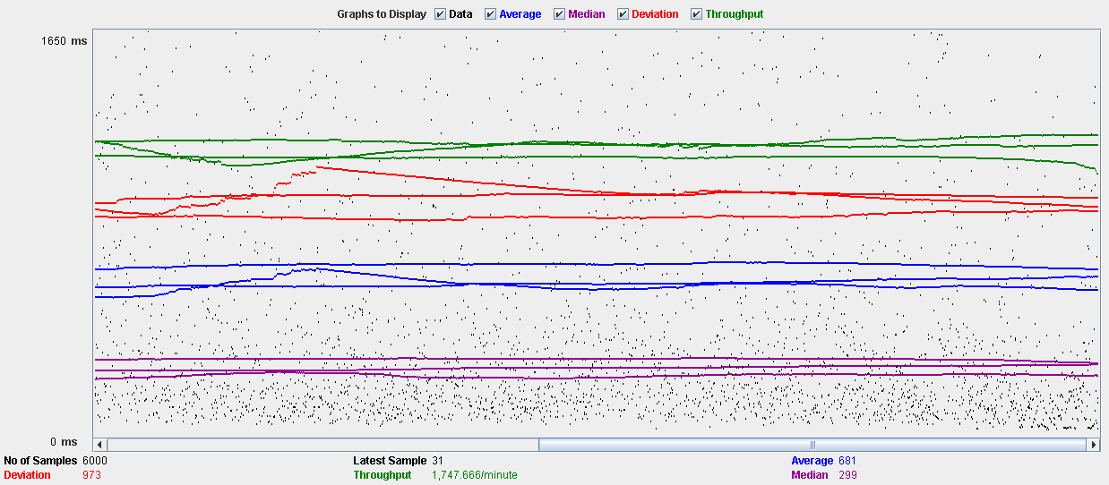

Performance Results:

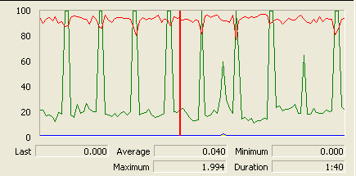

The CPU is always being used and disk show some peaks

## Delete

Sequence:

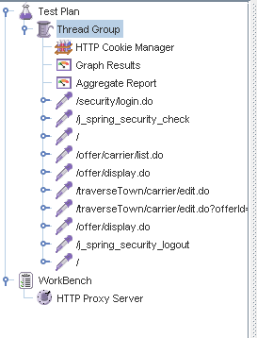

Aggregate Report:

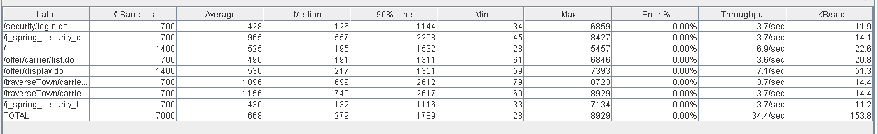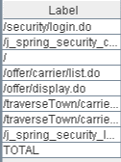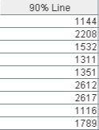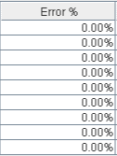

Thread properties:

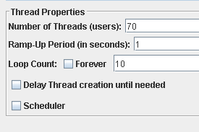

Graph Results:

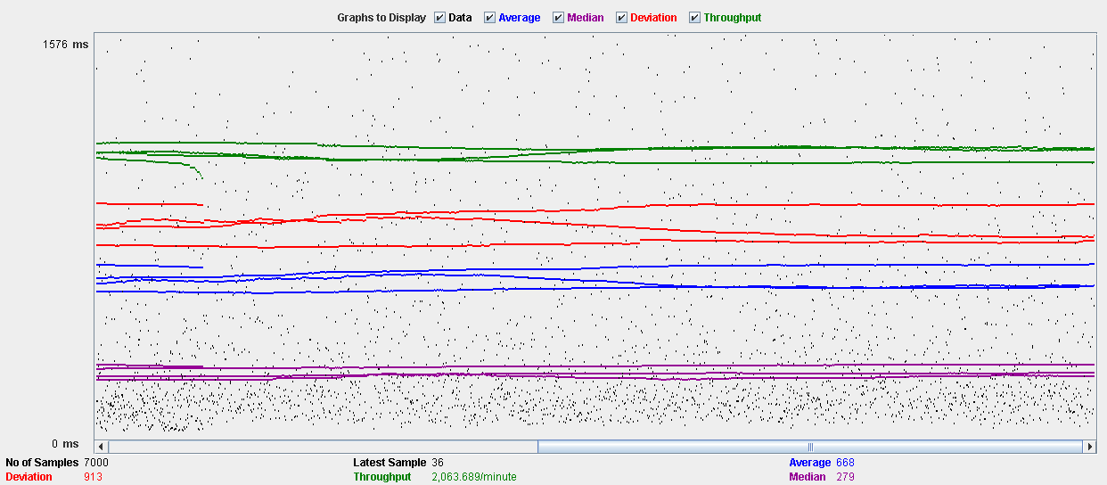

Performance Results:

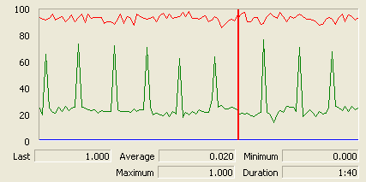

The CPU is always being used while the memory has some peaks.

## Conclusion

The test was performed using:

CPU: i5 2500k (2 cores in the virtual machine)

RAM: 2 GB (virtual machine)

For this use case we can say that the limitation occurs during the creation and edition process, being the maximum of concurrent users 60.

# Issue

## Create

Sequence:

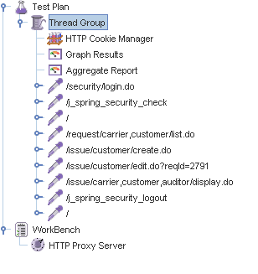

Aggregate Report:

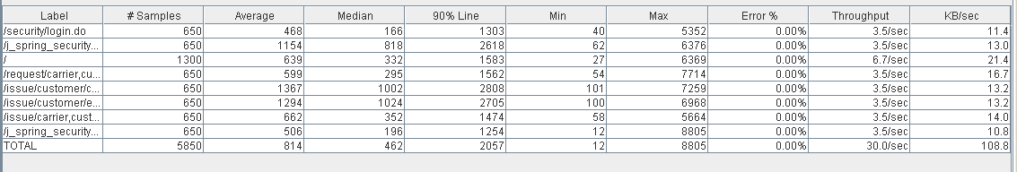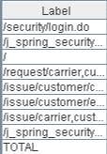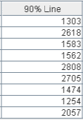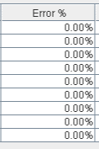

Thread properties:

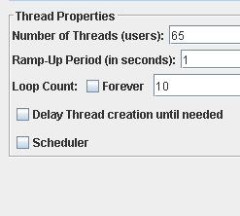

Graph Results:

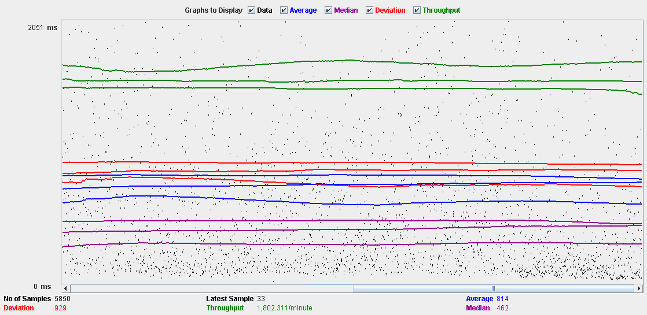

Performance Results:

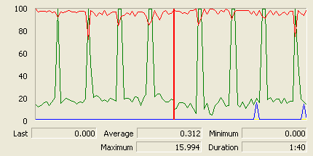

The CPU is always being used and physical disk usage show some peaks.

## Delete

Sequence:

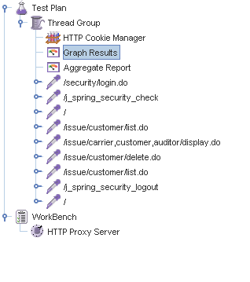

Aggregate Report:

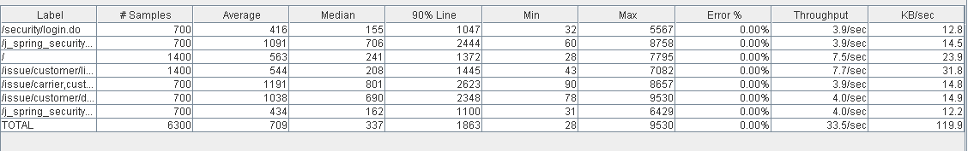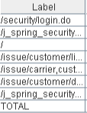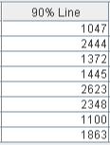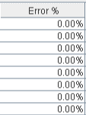

Thread properties:

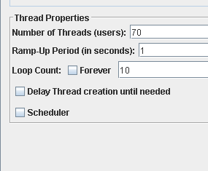

Graph Results:

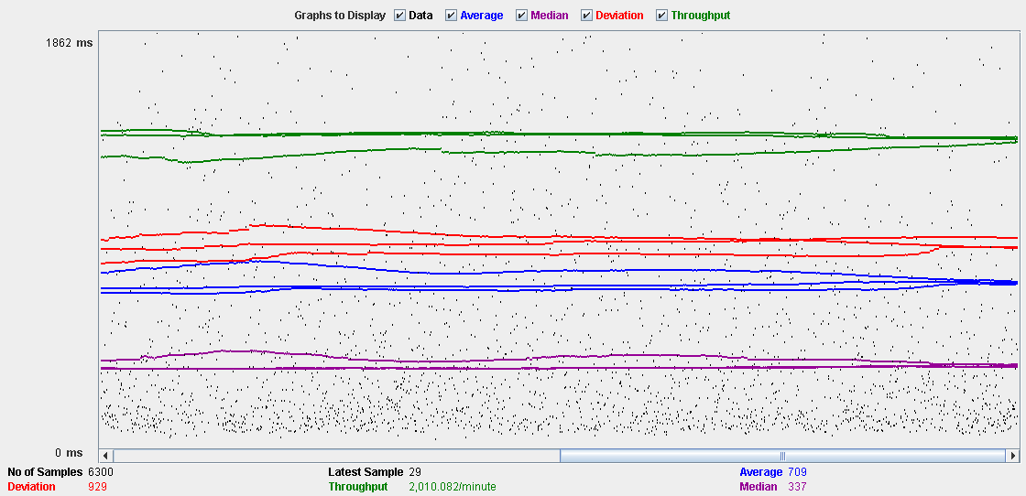

Performance Results:

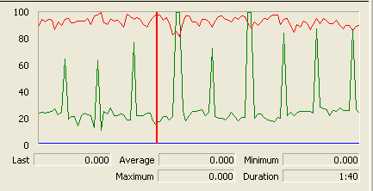

The CPU is always being used and disk show some peaks-

## Conclusion

The test was performed using:

CPU: i5 2500k (2 cores in the virtual machine)

RAM: 2 GB (virtual machine)

For this use case we can say that the limitation occurs during the create process, being the maximum of concurrent users 65.

# Town

## Create

Sequence:

Aggregate Report:

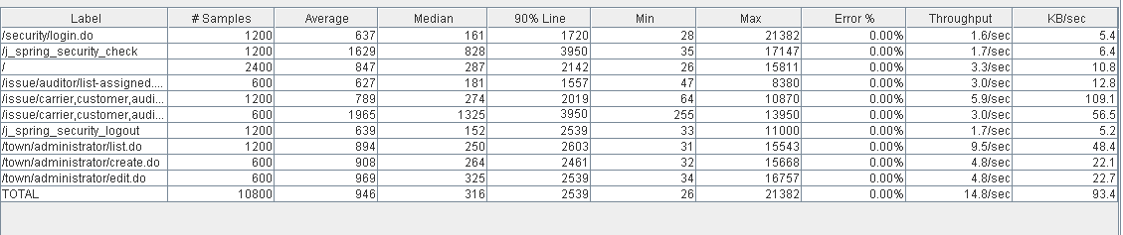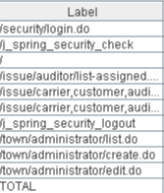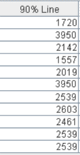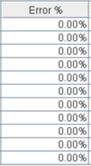

Thread properties:

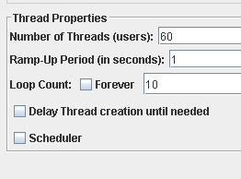

Graph Results:

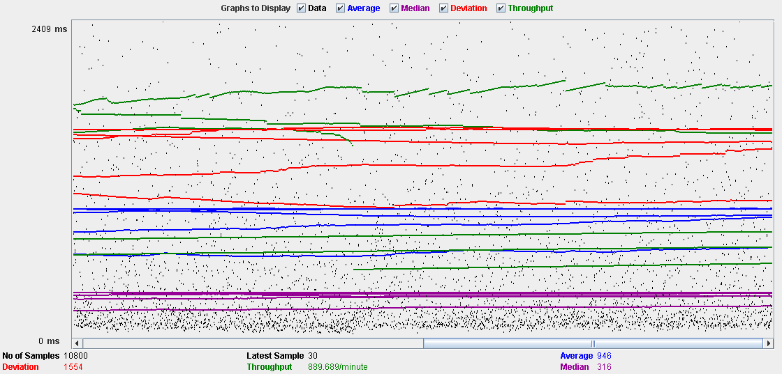

Performance Results:

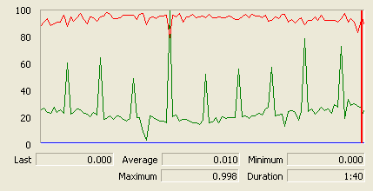

The CPU is always being used and physical disk usage show some peaks.

## Edit

Sequence:

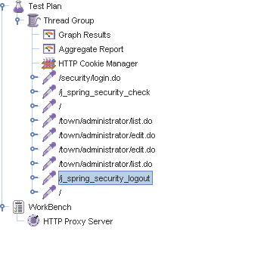

Aggregate Report:

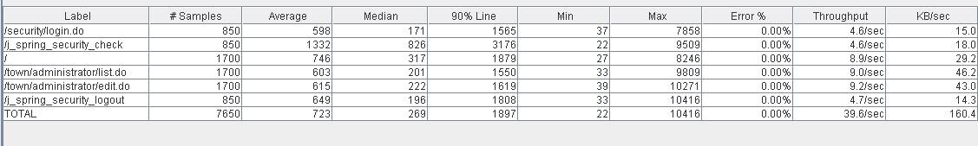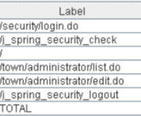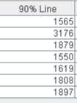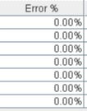

Thread properties:

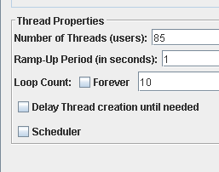

Graph Results:

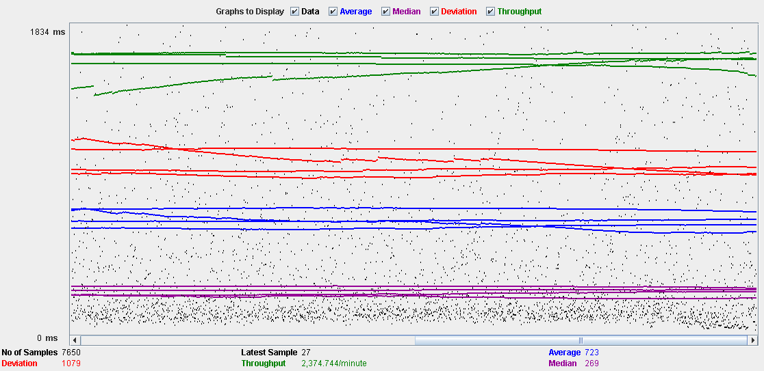

Performance Results:

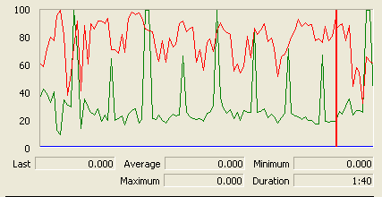

The CPU is always being used and small picks of physical disk

## Delete

Sequence:

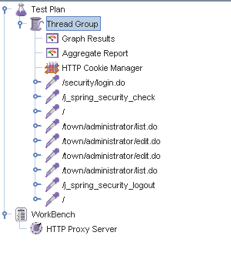

Aggregate Report:

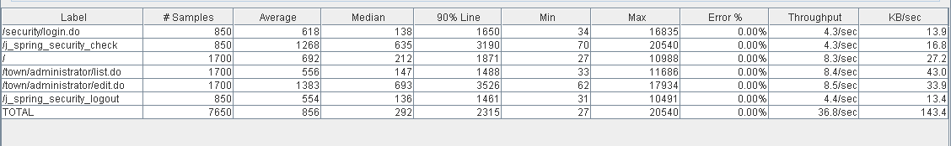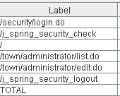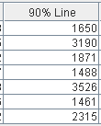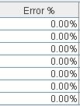

Thread properties:

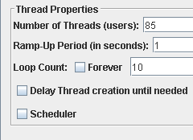

Graph Results:

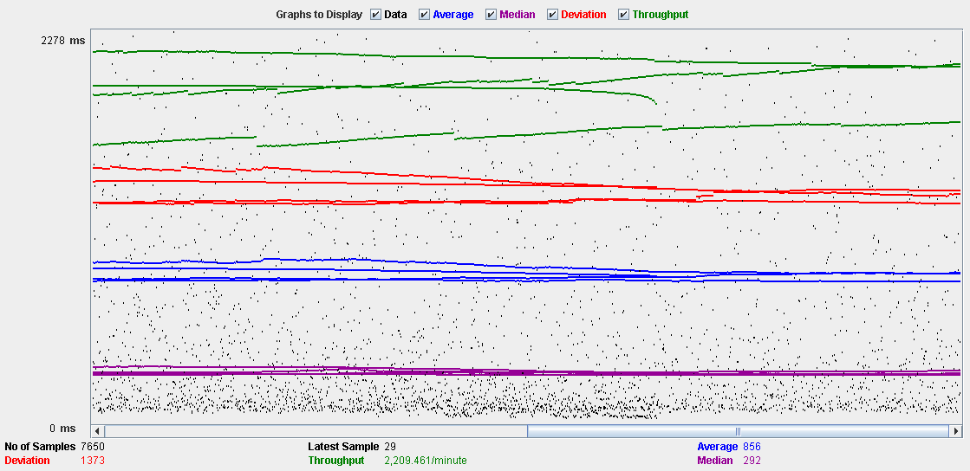

Performance Results:

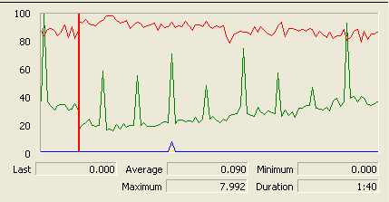

The CPU is always being used while the memory has some peaks.

## Conclusion

The test was performed using:

CPU: i5 2500k (2 cores in the virtual machine)

RAM: 2 GB (virtual machine)

For this use case we can say that the limitation occurs during the create process, being the maximum of concurrent users 60.

# Comment

## Create

Sequence:

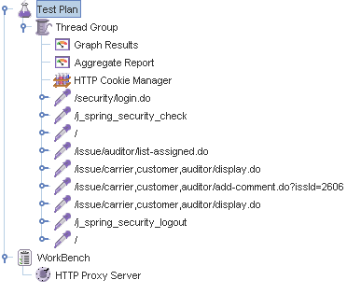

Aggregate Report:

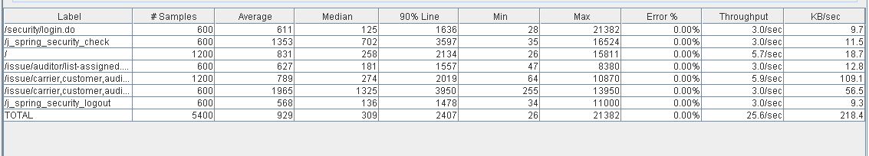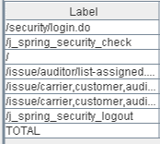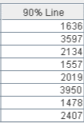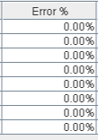

Thread properties:

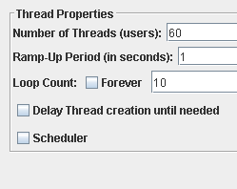

Graph Results:

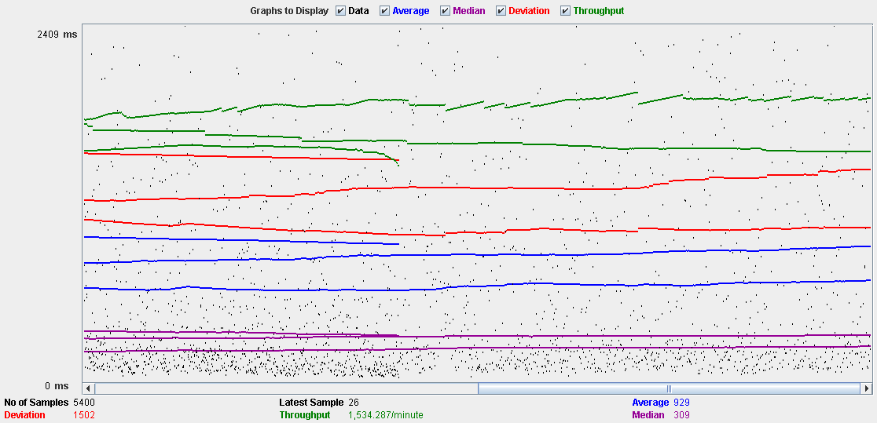

Performance Results:

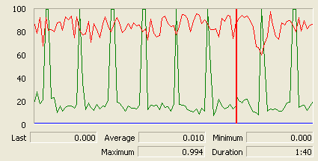

The CPU is always being used and physical disk usage is barely noticeable.

## Conclusion

The test was performed using:

CPU: i5 2500k (2 cores in the virtual machine)

RAM: 2 GB (virtual machine)

For this use case we can say that the limitation occurs with 60 users.

# Configuration

## Display and edit

Sequence:

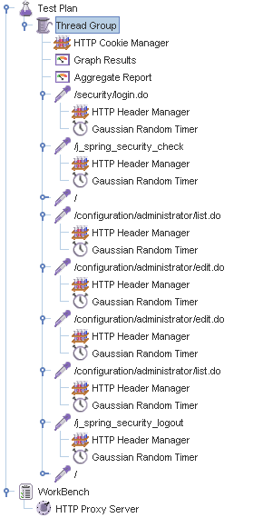

Aggregate Report:

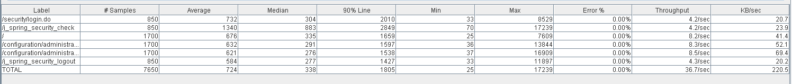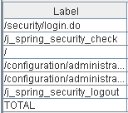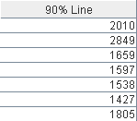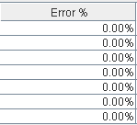

Thread properties:

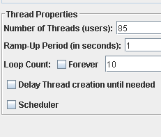

Graph Results:

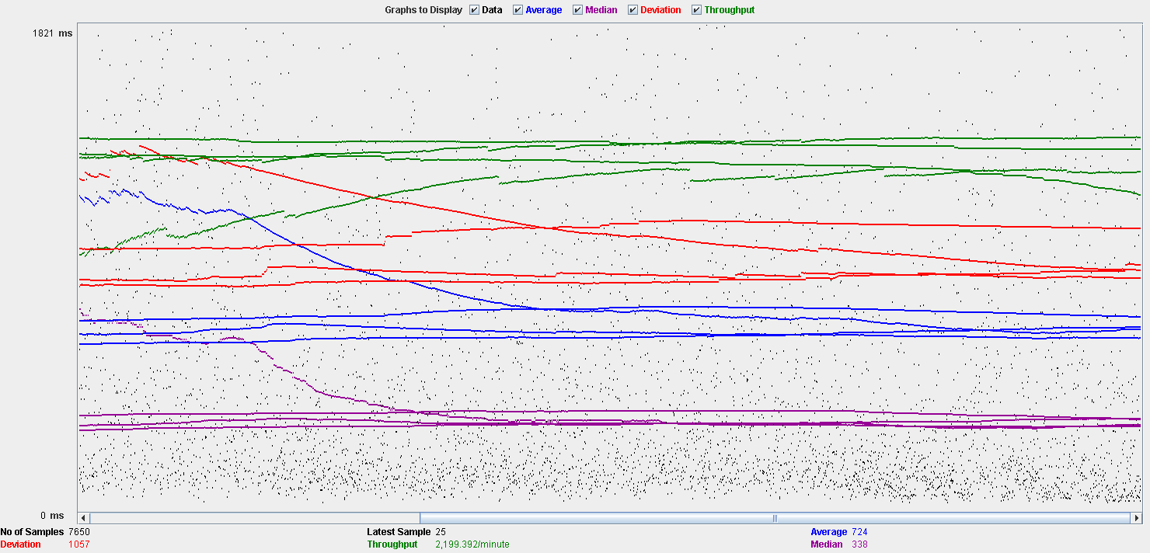

Performance Results:

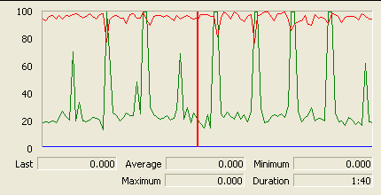

The CPU is always being used and physical disk usage show some peaks.

## Conclusion

The test was performed using:

CPU: i5 2500k (2 cores in the virtual machine)

RAM: 2 GB (virtual machine)

For this use case we can say that the limitation occurs during the edition process, being the maximum of concurrent users 85.

# Finder

## Search

Sequence:

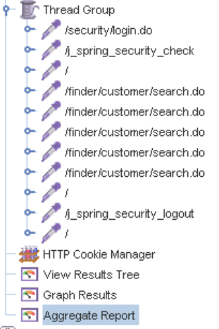

Aggregate Report:

 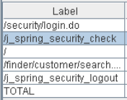 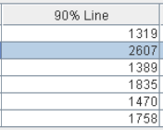 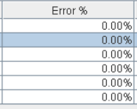

Thread properties:

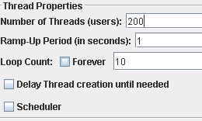

Graph Results:

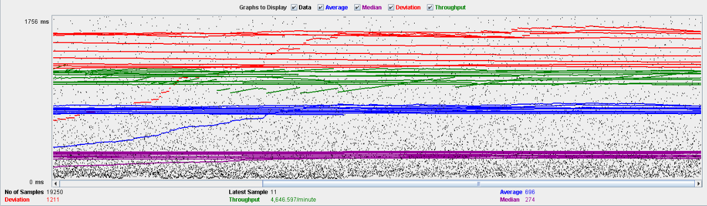

Performance Results:

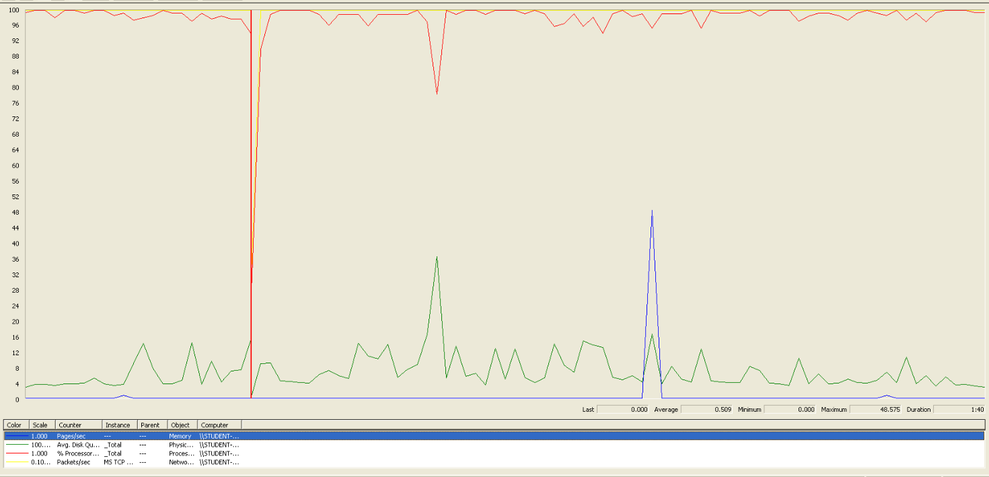

We can clearly see that the bottleneck is the CPU.

## Conclusion

The test was performed using:

CPU: i5 7300HQ (2 cores in the virtual machine)

RAM: 2 GB (virtual machine)

For this use case we can say that the maximum of concurrent users is about 200.

# Offer

## Create/Edit

Sequence:

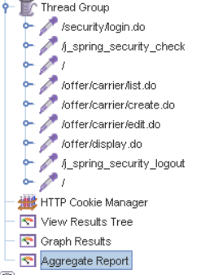

Aggregate Report:

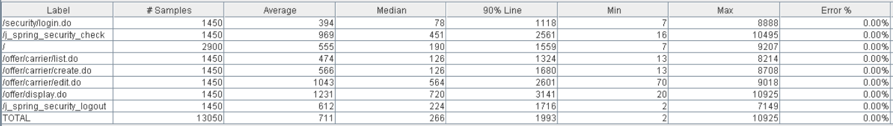 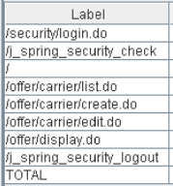 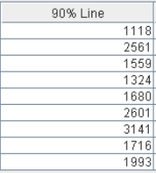 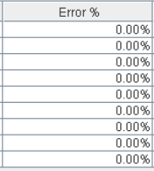

Thread properties:

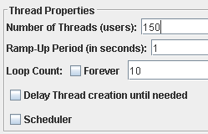

Graph Results:

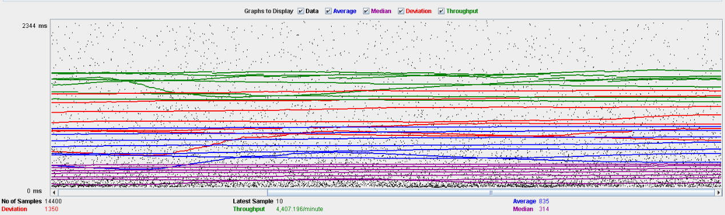

Performance Results:

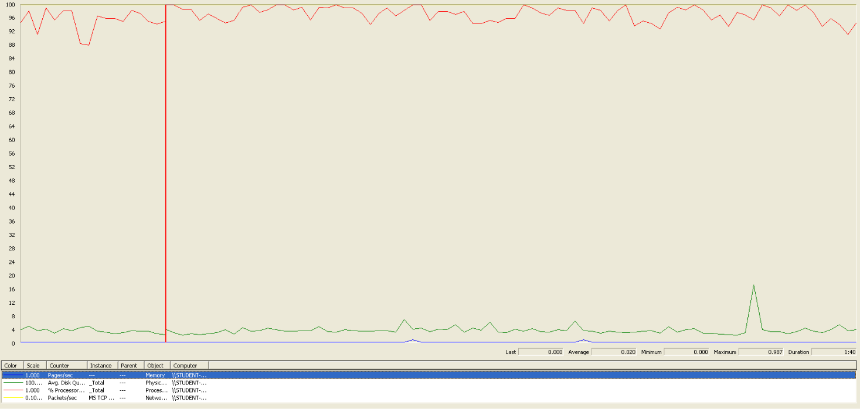

We can clearly see that the bottleneck is the CPU.

## Delete

Sequence:

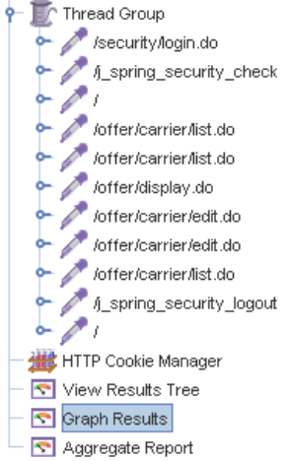

Aggregate Report:

 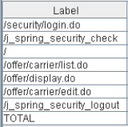 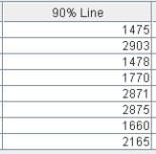 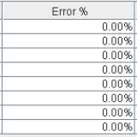

Thread properties:

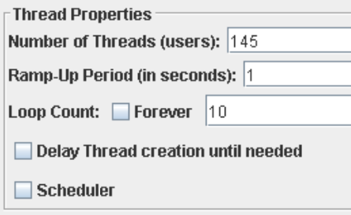

Graph Results:

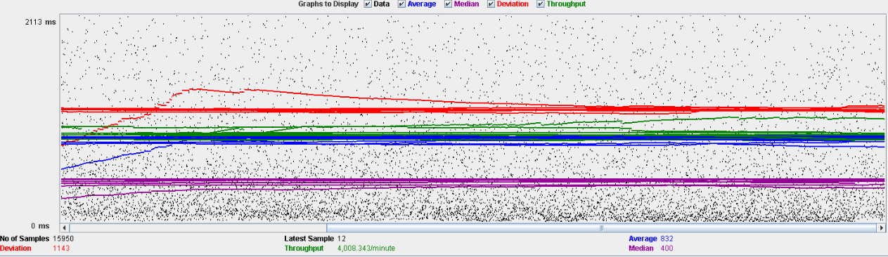

Performance Results:

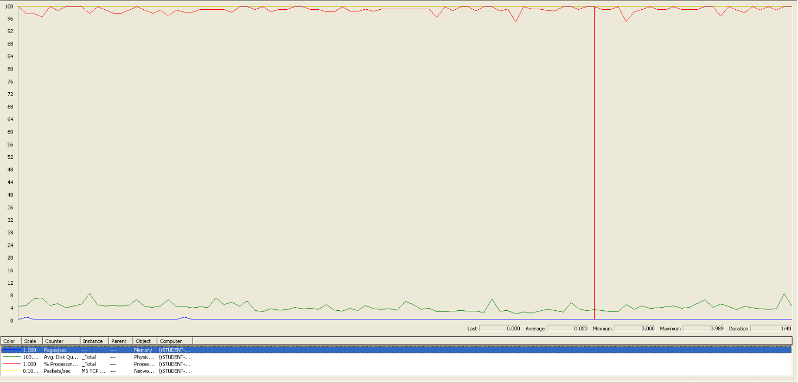

We can clearly see, another time, that the bottleneck is the CPU.

## Conclusion

The test was performed using:

CPU: i5 7300HQ (2 cores in the virtual machine)

RAM: 2 GB (virtual machine)

For this use case we can say that the maximum of concurrent users is about 145, delimited by the delete.

# Curricula

## Create a curriculum

Sequence:

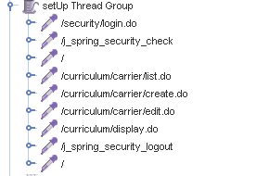

Aggregate Report:

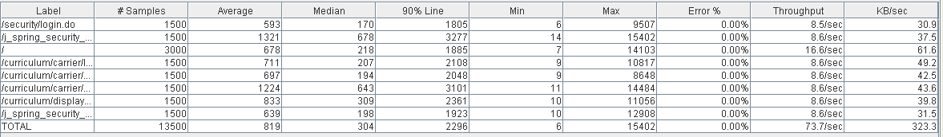

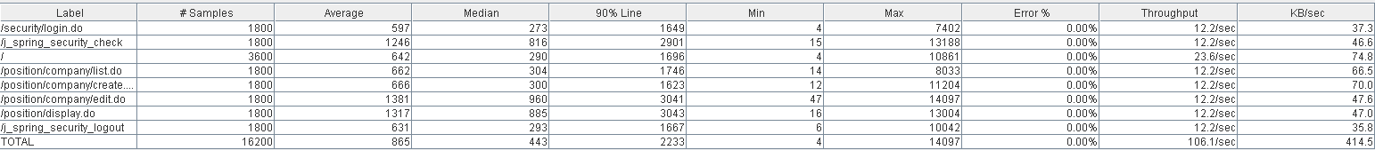

Thread properties:



Graph Results:

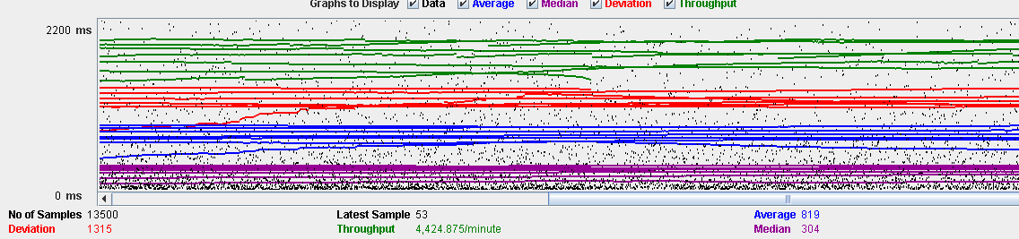

Performance Results:

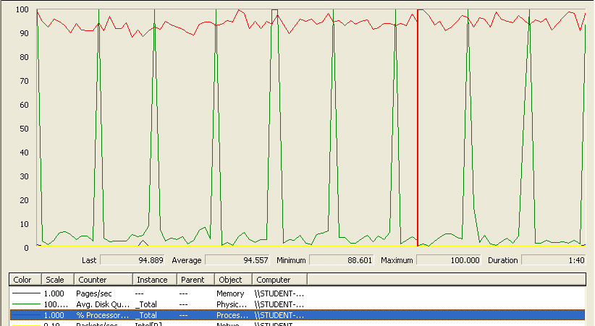

The CPU was always at its limit while the disk usage showed many peaks.

## Edit a curriculum

Sequence:

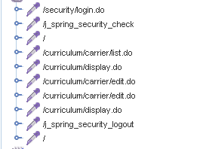

Aggregate Report:

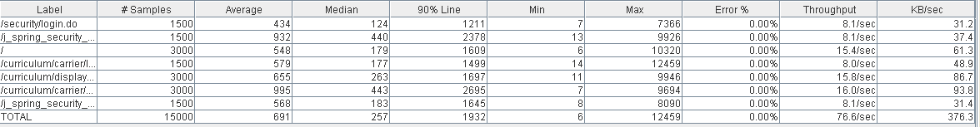



Thread properties:



Graph Results:

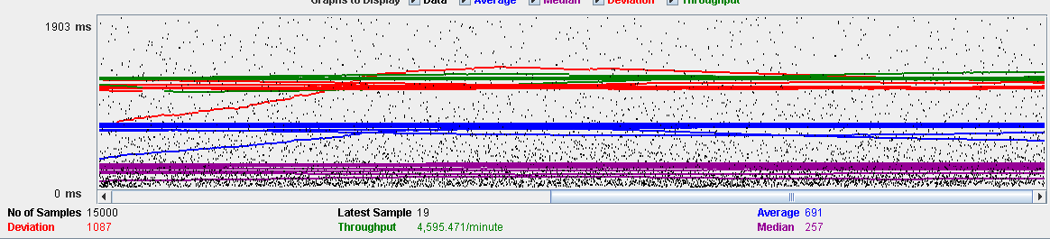

Performance Results:

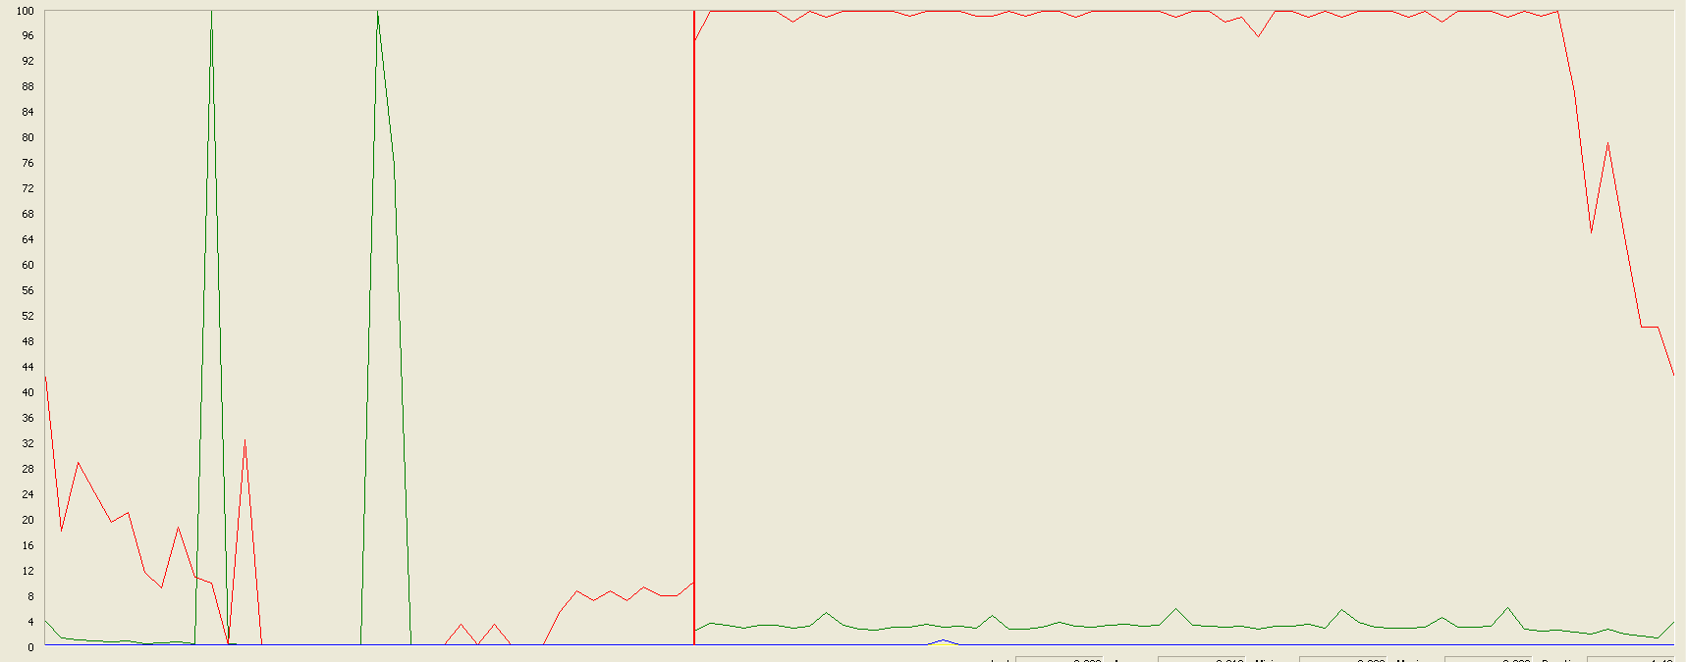

The CPU was always at its limit while the disk usage showed many peaks.

## Delete a curriculum

Sequence:

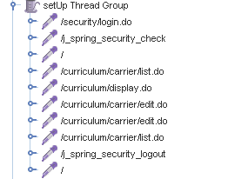

Aggregate Report:

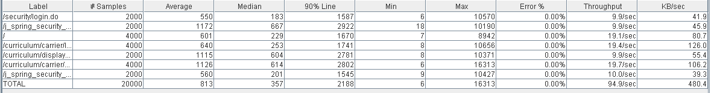



Thread properties:

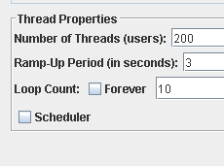

Graph Results:

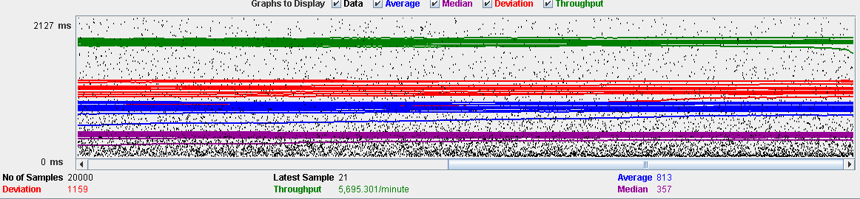

Performance Results:

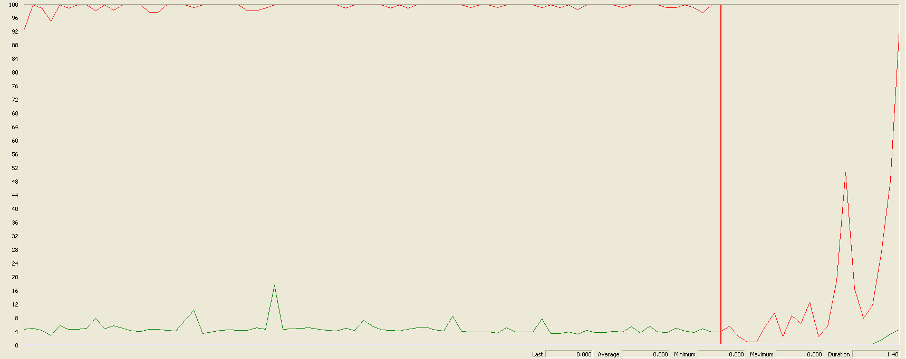

Again we can see that the CPU is always being used while the disk usage shows some little peaks.

## Conclusion

The test was performed using:

CPU: i7 7700hq (2 cores in the virtual machine)

RAM: 2 GB (virtual machine)

For this use case we can say that the limitation occurs during the creation and edition process, being the maximum of concurrent users 150.

# Records (Professional and Miscellaneous record)

## Create Miscellaneous Record

Sequence:

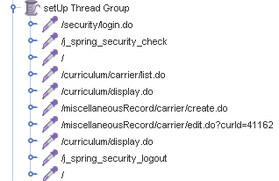

Aggregate Report:

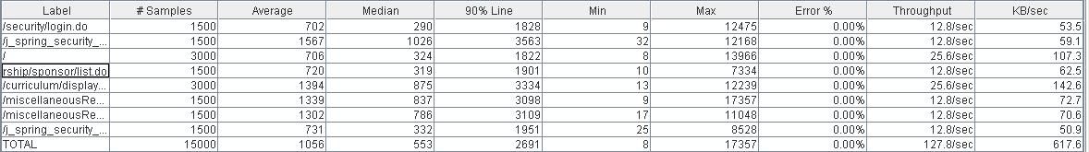



Thread properties:

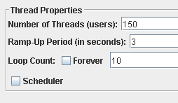

Graph Results:

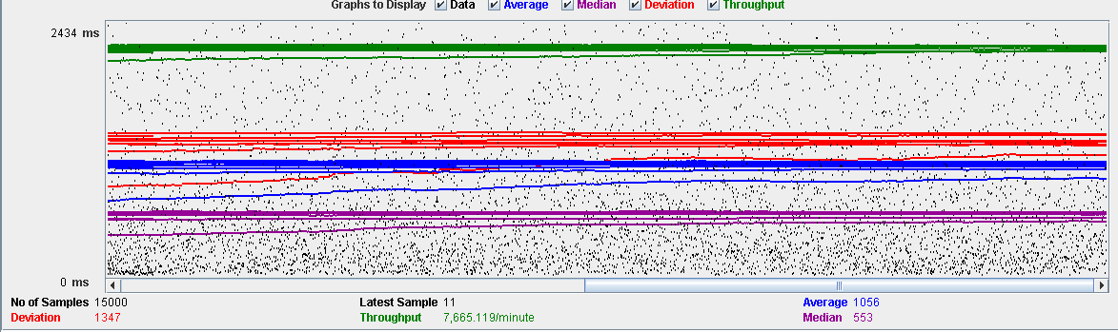

Performance Results:

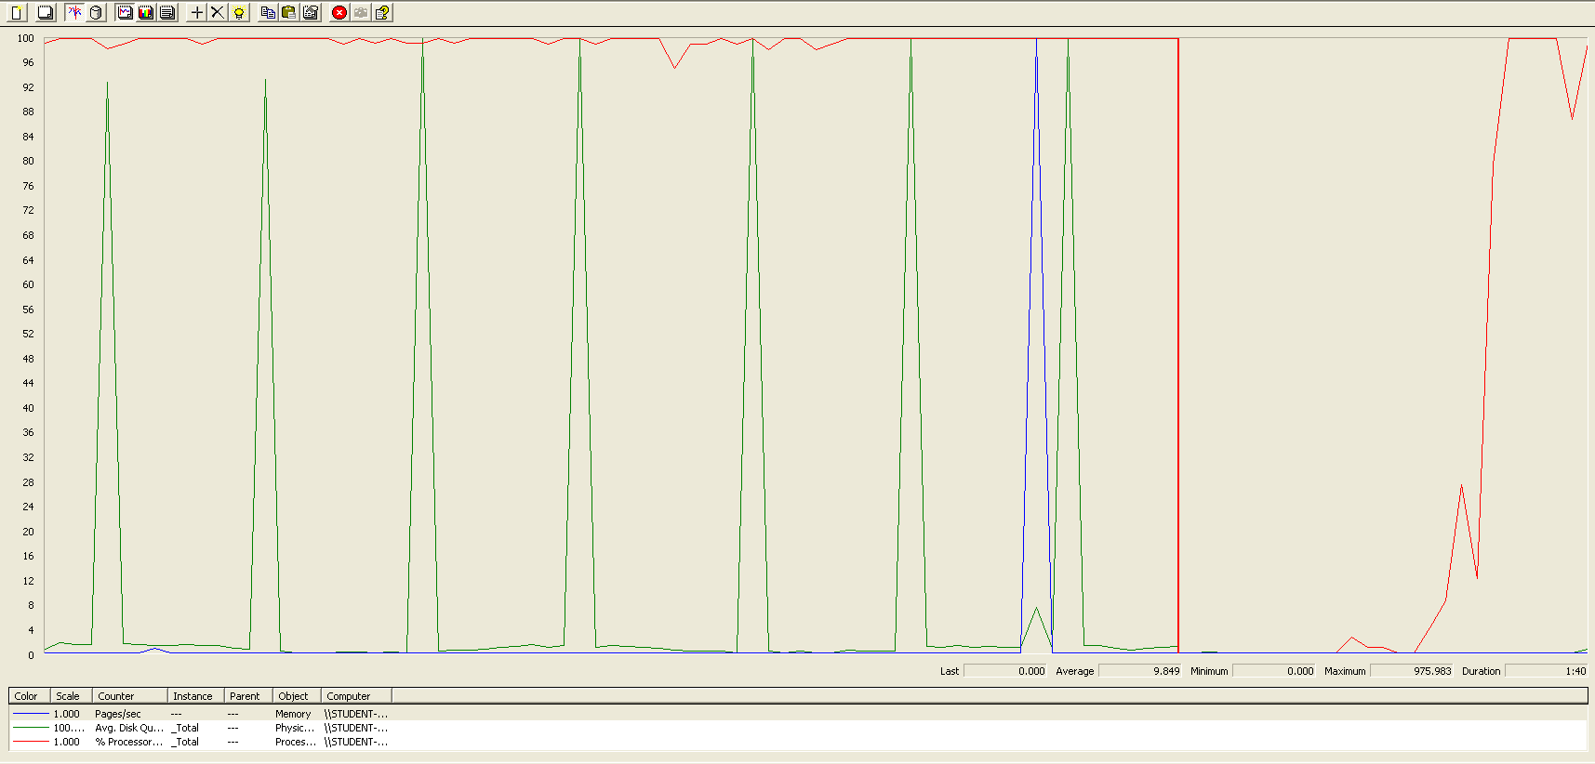

Again we can see that the CPU is always being used while the disk usage shows some periodic peaks.

## Create Professional Record

Sequence:



Aggregate Report:

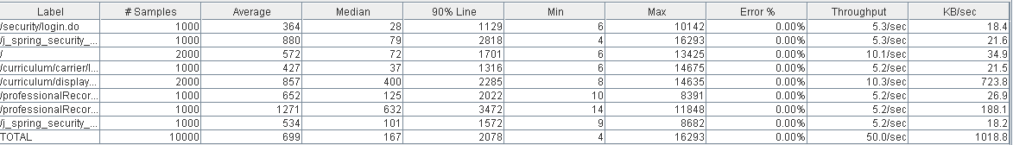



Thread properties:

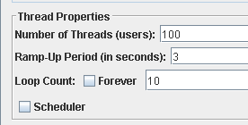

Graph Results:

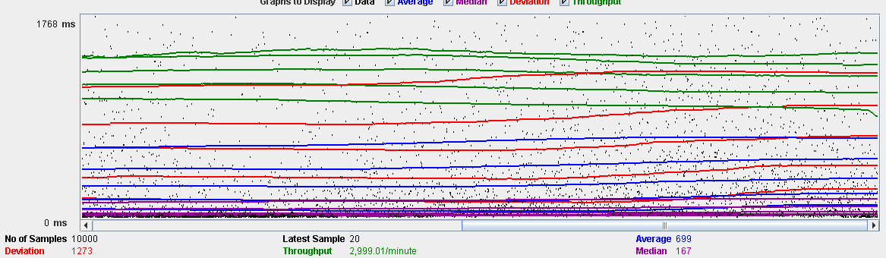

Performance Results:

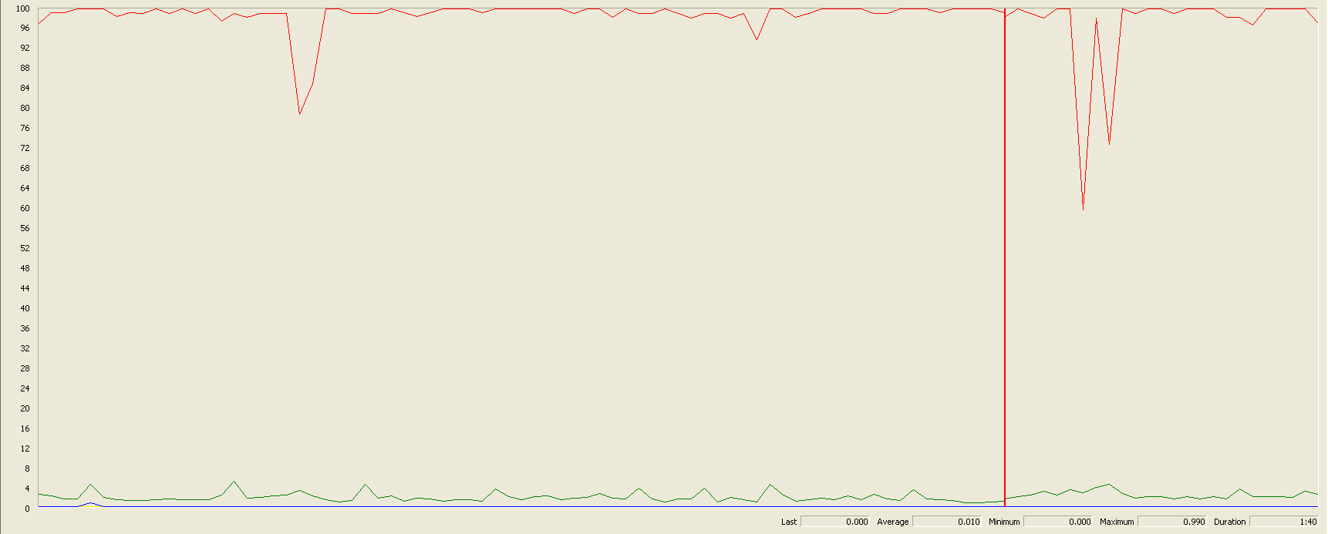

Again we can see that the CPU is always being used while the disk usage shows some low peaks

## Edit a Miscellaneous Record

Sequence:

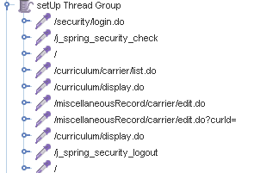

Aggregate Report:

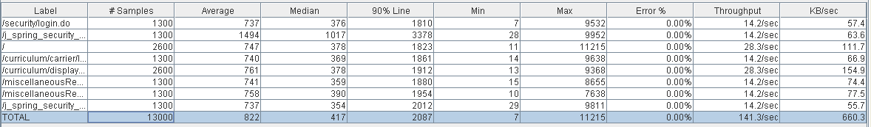



Thread properties:

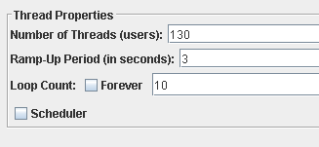

Graph Results:

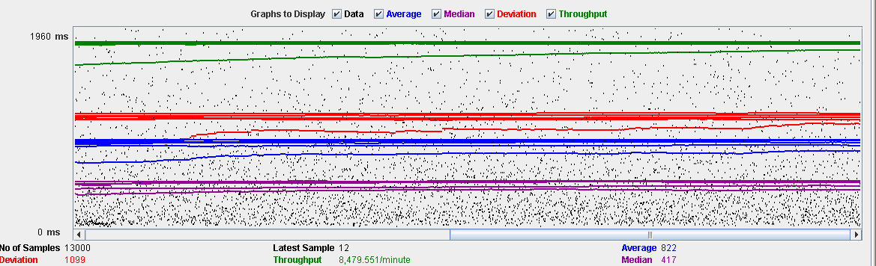

Performance Results:

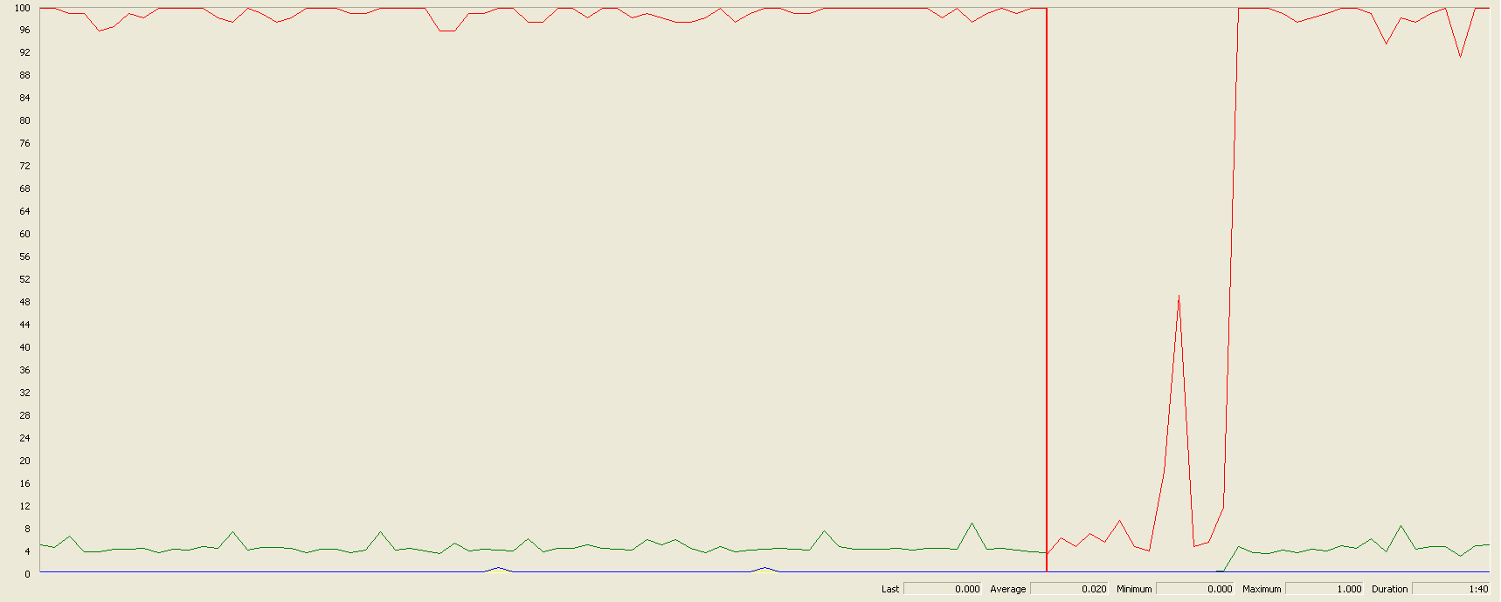

Again we can see that the CPU is always being used while the disk usage shows some peaks.

## Edit a Professional Record

Sequence:

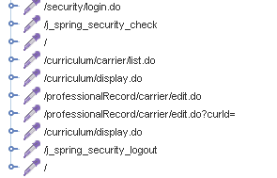

Aggregate Report:

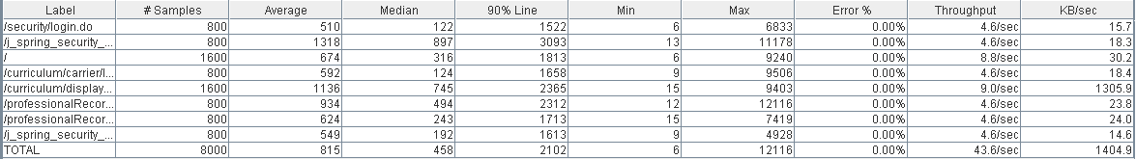



Thread properties:

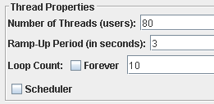

Graph Results:

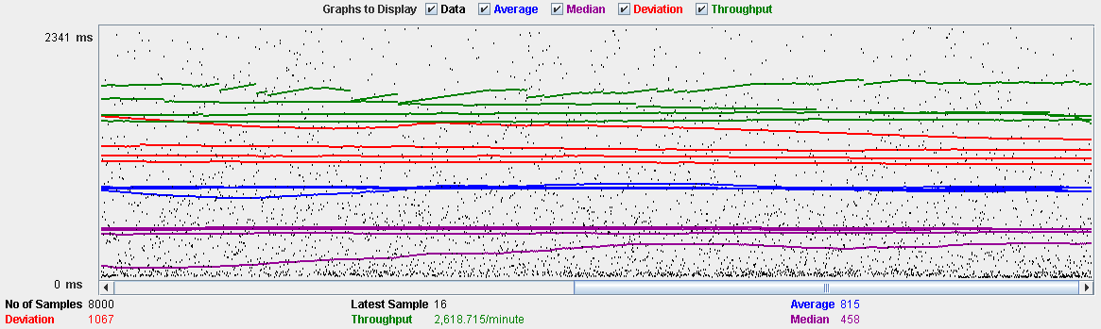

Performance Results:

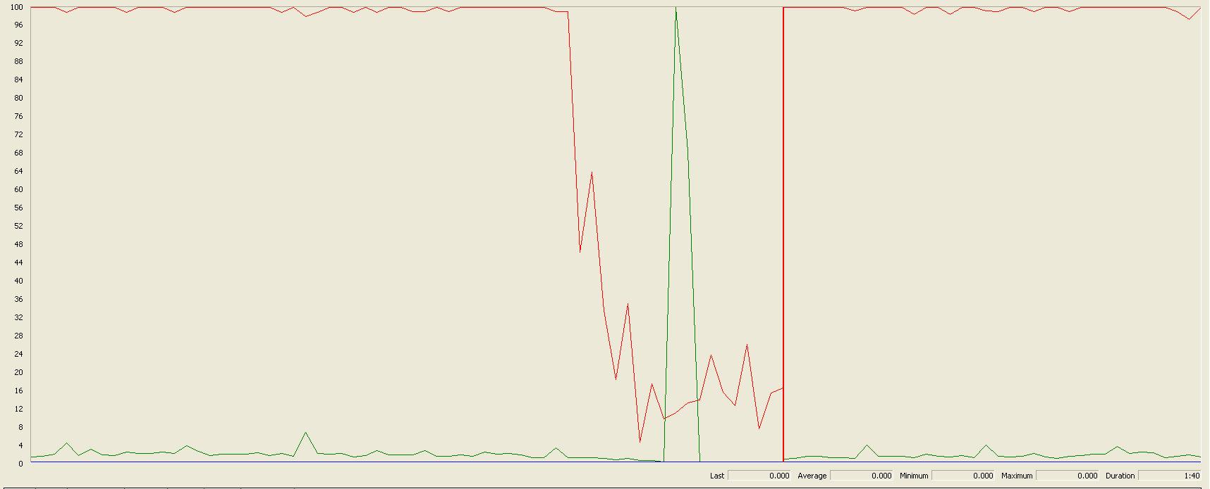

Again we can see that the CPU is always being used while the disk usage shows some peaks.

## Delete a professional record

Sequence:



Aggregate Report:

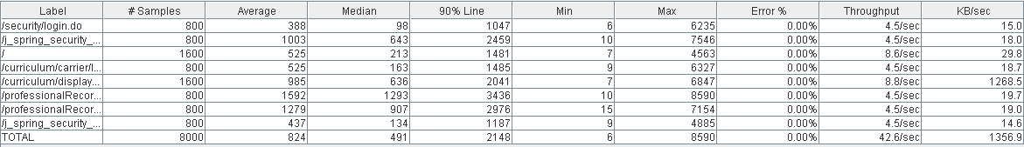

 

Thread properties:

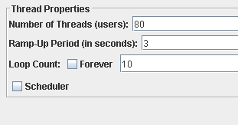

Graph Results:

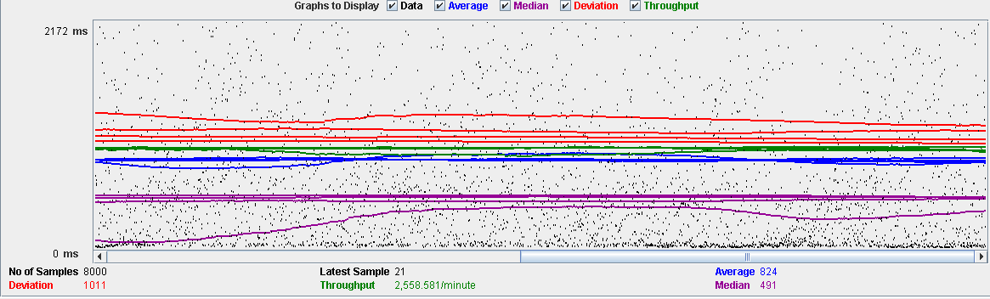

Performance Results:

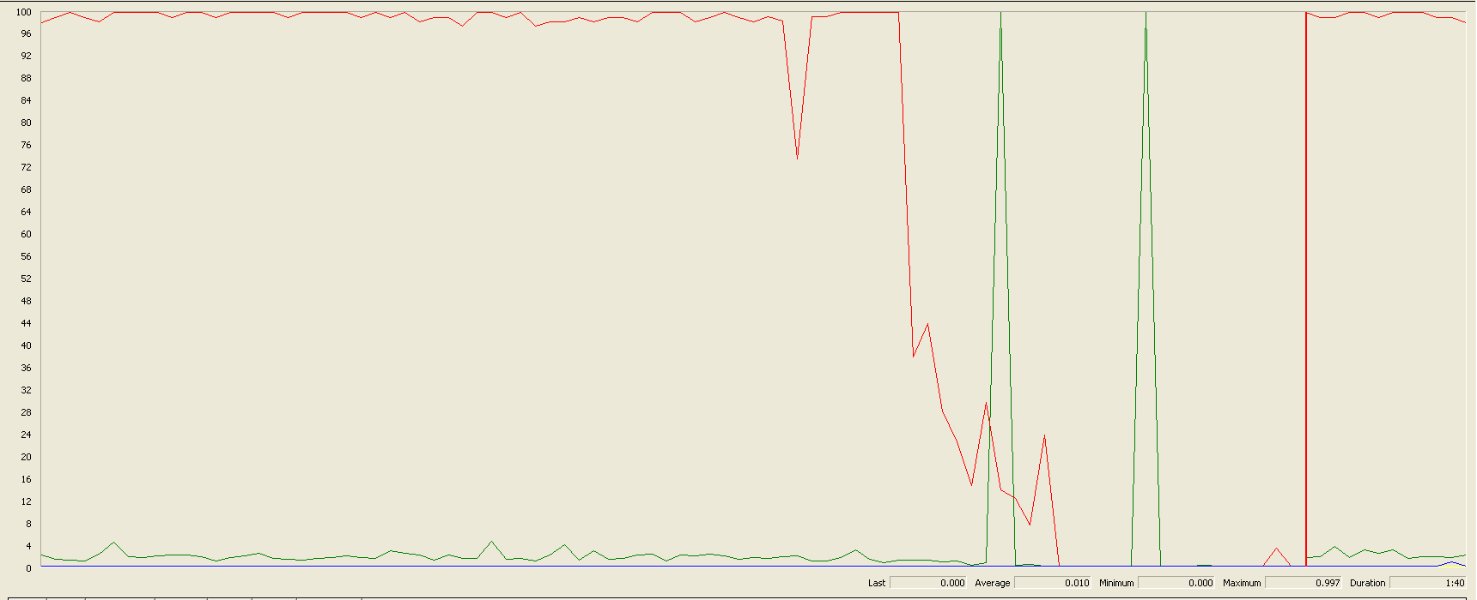

Again we can see that the CPU is always being used while the disk usage shows two peaks.

## Delete a miscellaneous data

Sequence:



Aggregate Report:

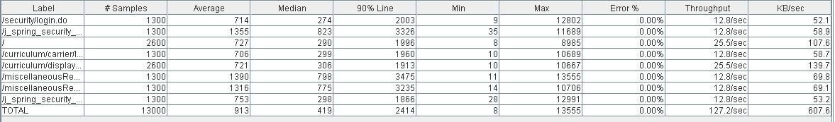

 

Thread properties:



Graph Results:

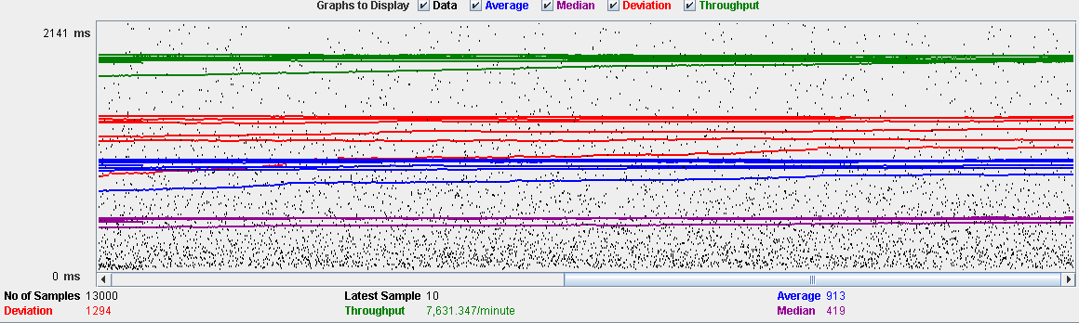

Performance Results:

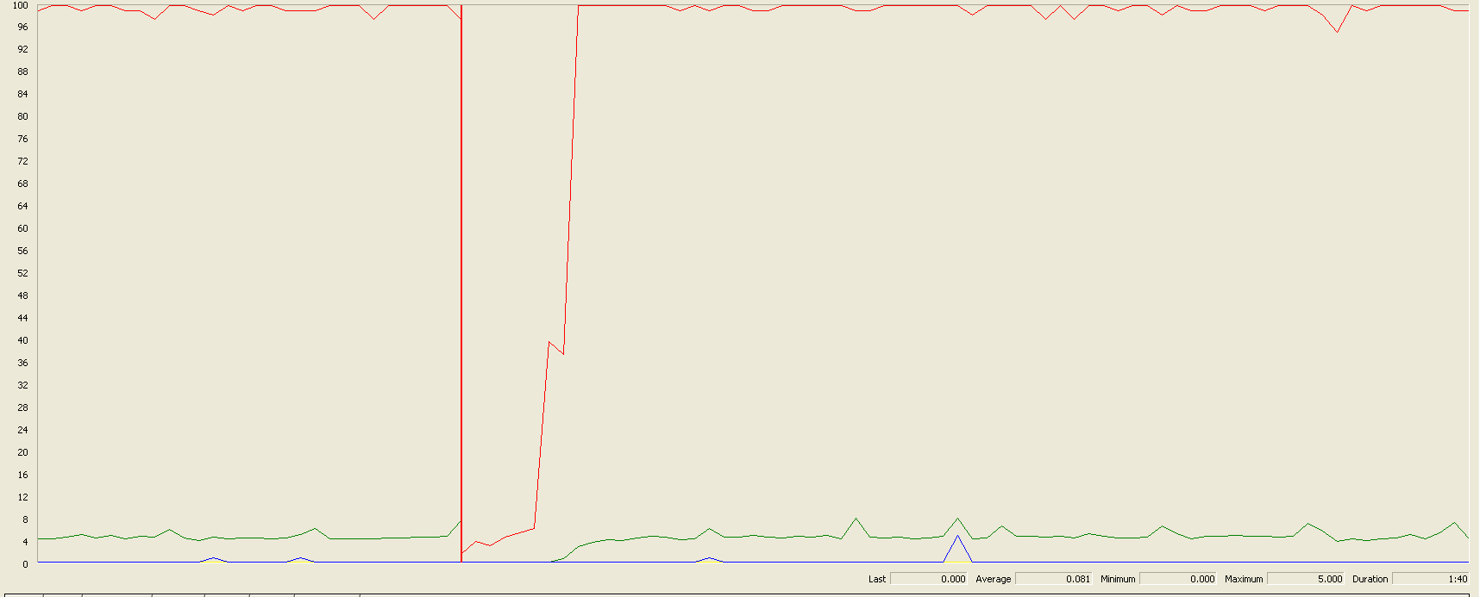

Again we can see that the CPU is always being used while the disk usage shows little peaks.

## Conclusion

The test was performed using:

CPU: i7 6700hq (2 cores in the virtual machine)

RAM: 4 GB (virtual machine)

For this use case we can say that the limitation occurs during the creation process, being the maximum of concurrent users 80.

# Actor

## Create

Sequence:

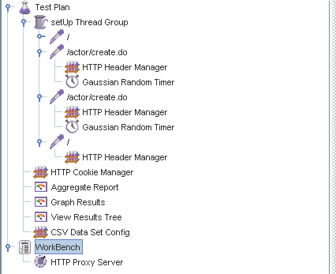

Aggregate Report:



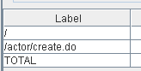  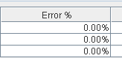

Thread properties:



Graph Results:

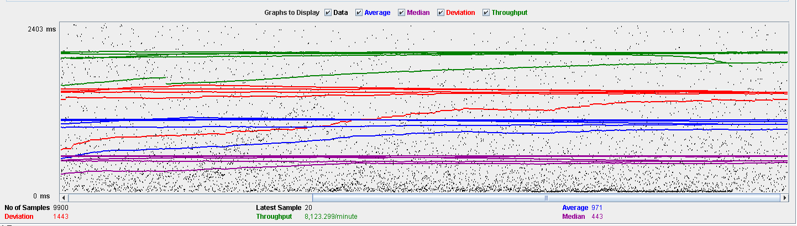

Performance Results:

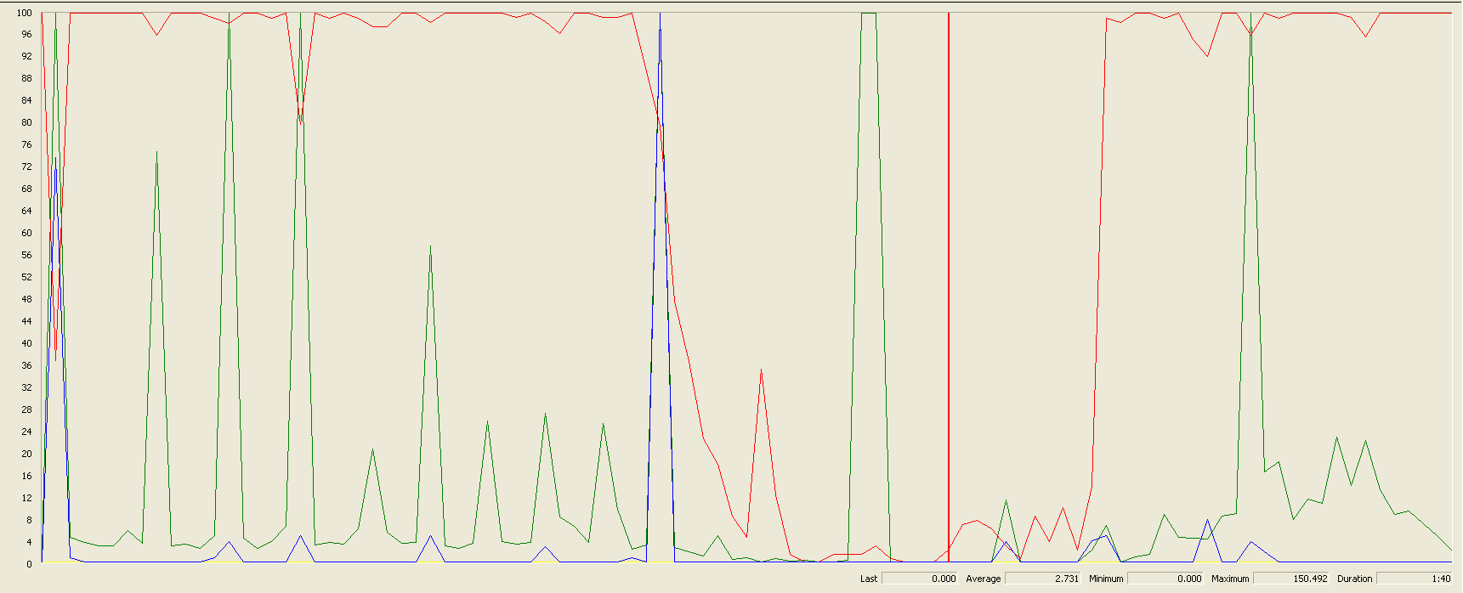

The CPU was always at its limit while the disk usage has a lot of peaks.

## Edit

Sequence:

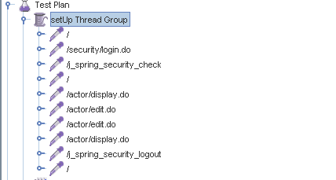

Aggregate Report:

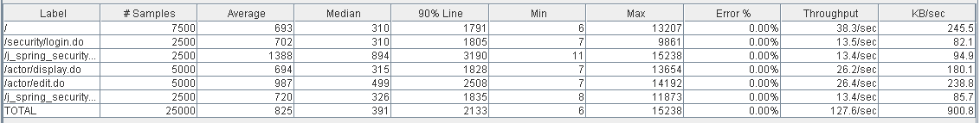



Thread properties:



Graph Results:

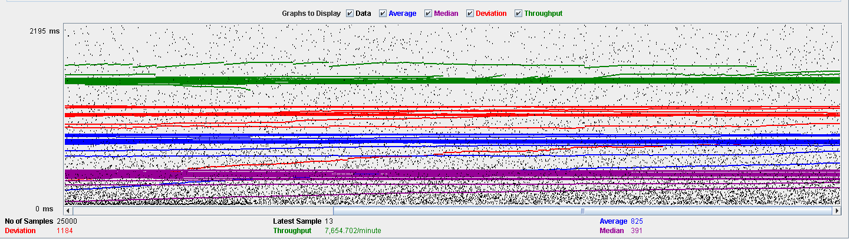

Performance Results:

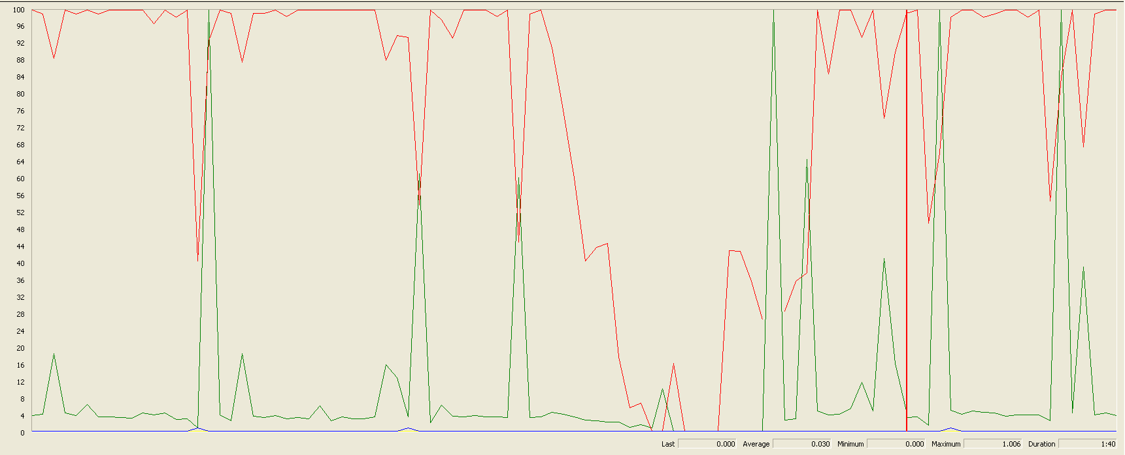

Again we can see that the CPU is always being used while the disk usage has some peaks at times.

## Delete

Sequence:

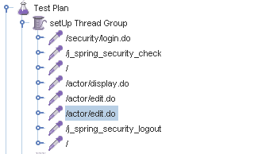

Aggregate Report:



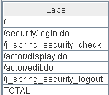

Thread properties:

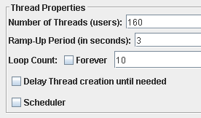

Graph Results:

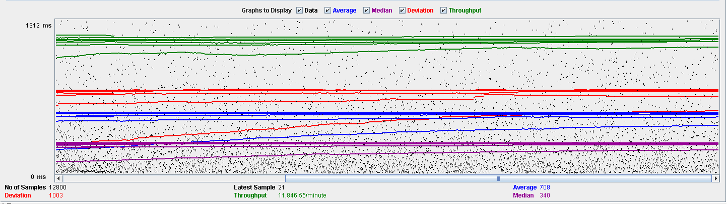

Performance Results:

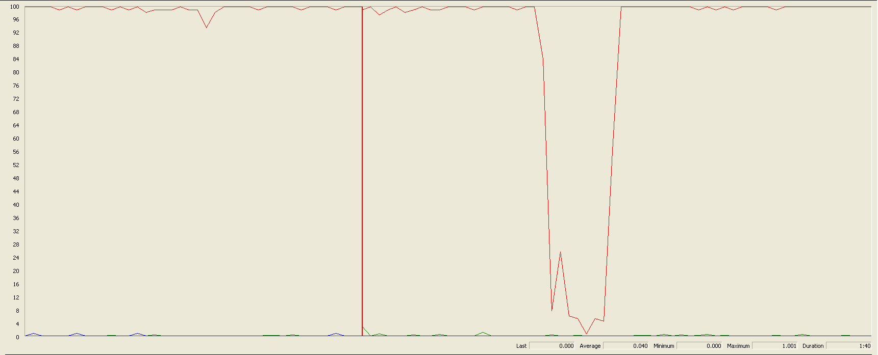

Again we can see that the CPU is always being used while the disk usage has different peaks.

## Conclusion

The test was performed using:

CPU: i7 7700hq (2 cores in the virtual machine)

RAM: 4 GB (virtual machine)

For this use case we can say that the limitation occurs during the creation process, being the maximum of concurrent users is 90.

# Vehicle

## Create

Sequence:

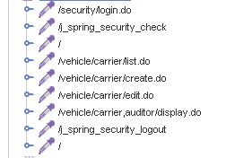

Aggregate Report:

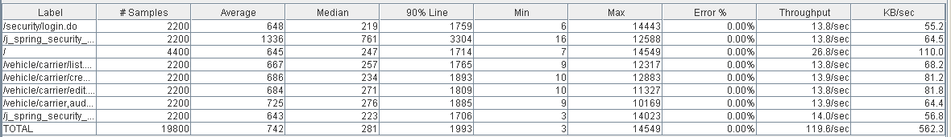



Thread properties:

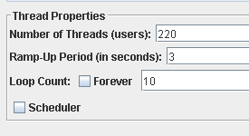

Graph Results:

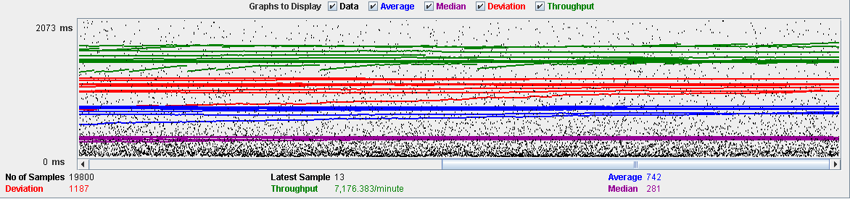

Performance Results:

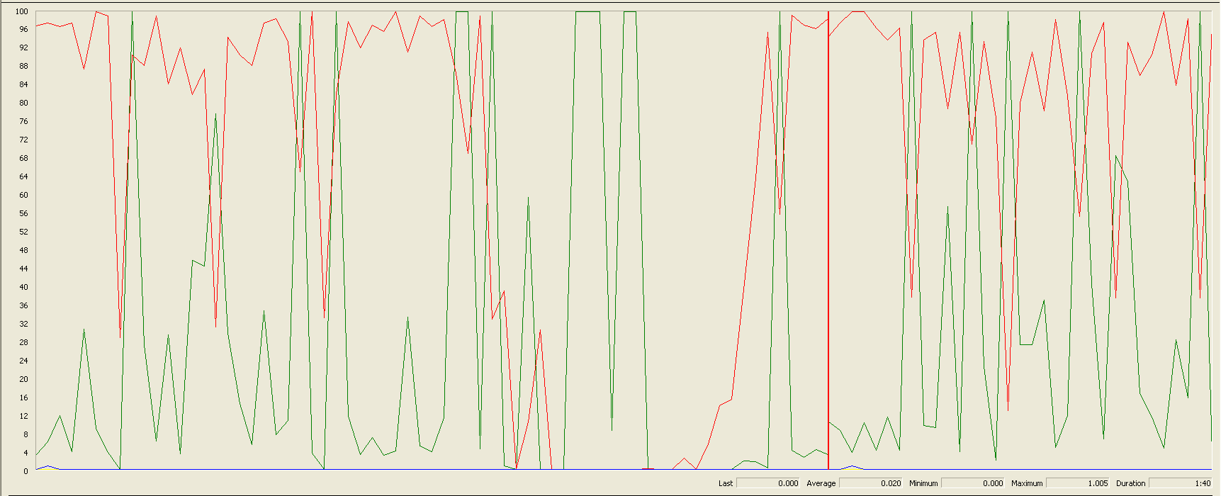

The CPU was always at its limit while the disk usage has many peaks.

## Edit

Sequence:



Aggregate Report: 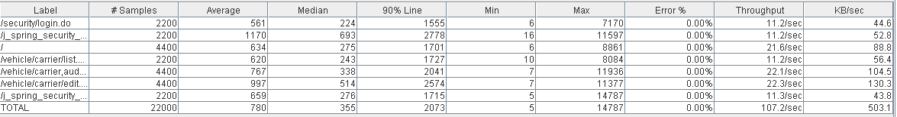



Thread properties:

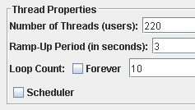

Graph Results:

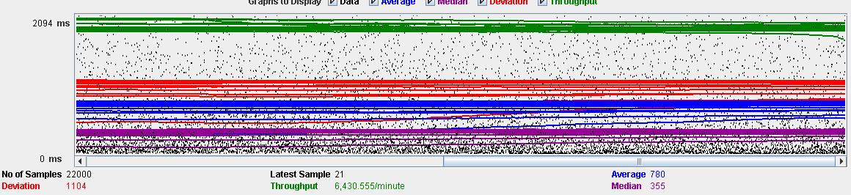

Performance Results:

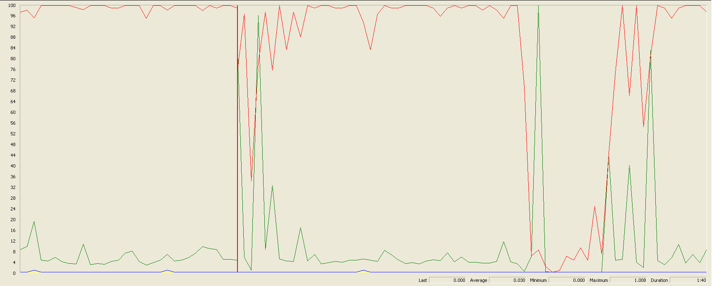

Again we can see that the CPU is always being used while the disk usage has high peaks at times.

## Delete

Sequence:

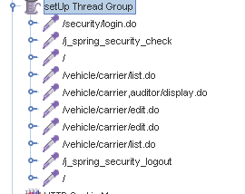

Aggregate Report:

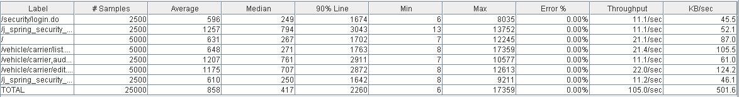



Thread properties:

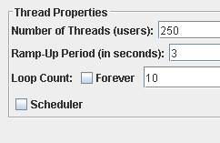

Graph Results:

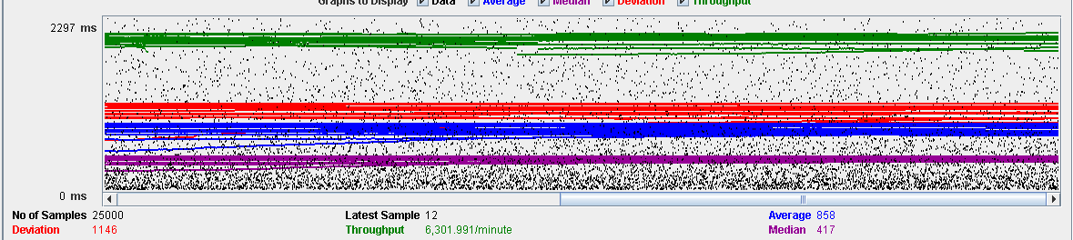

Performance Results:

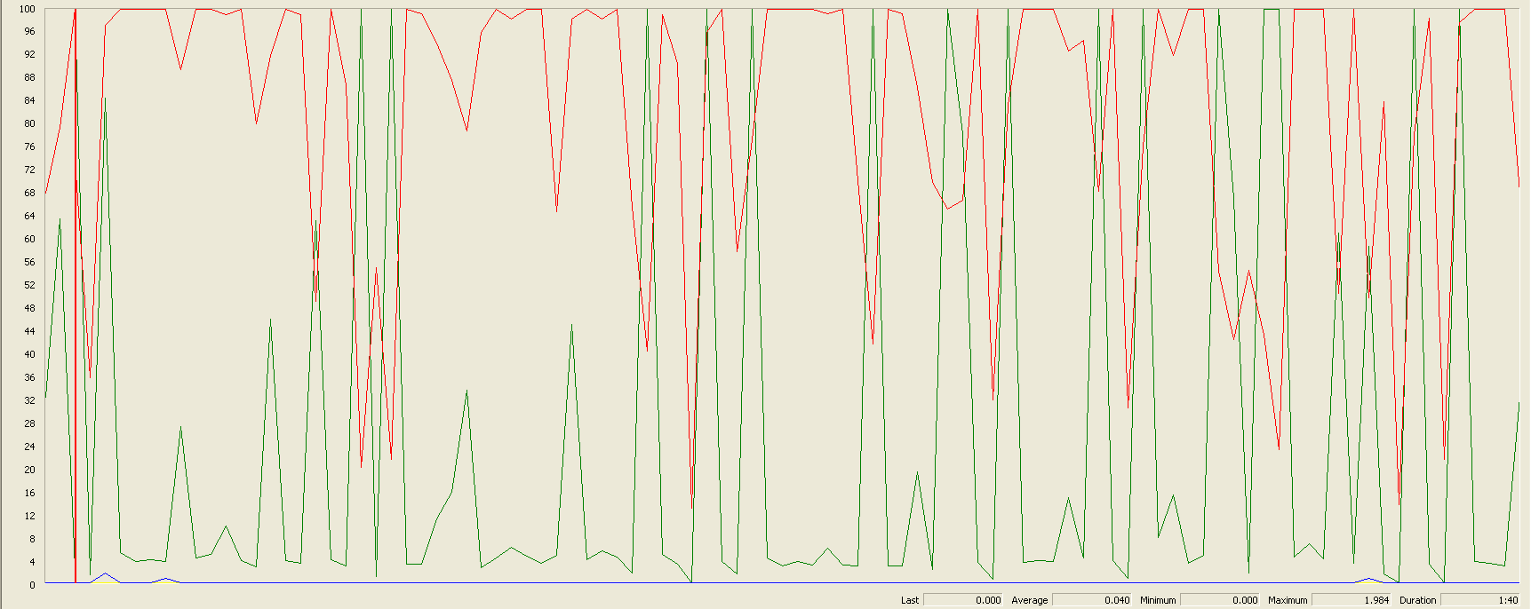

Again we can see that the CPU is always being used while the disk usage has many different peaks.

## Conclusion

The test was performed using:

CPU: i7 7700hq (2 cores in the virtual machine)

RAM: 4 GB (virtual machine)

For this use case we can say that the limitation occurs during the creation process, being the maximum of concurrent users 220.

# Solicitation

## Create

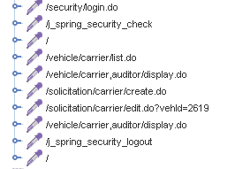

Aggregate Report:

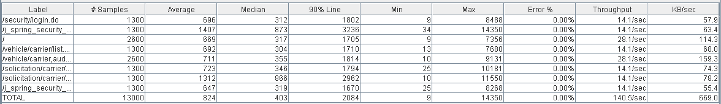

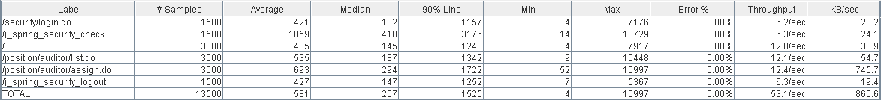

Thread properties:

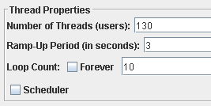

Graph Results:

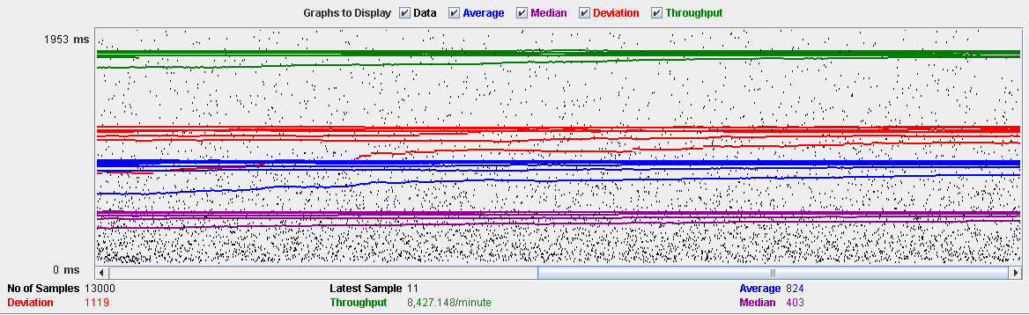

Performance Results:

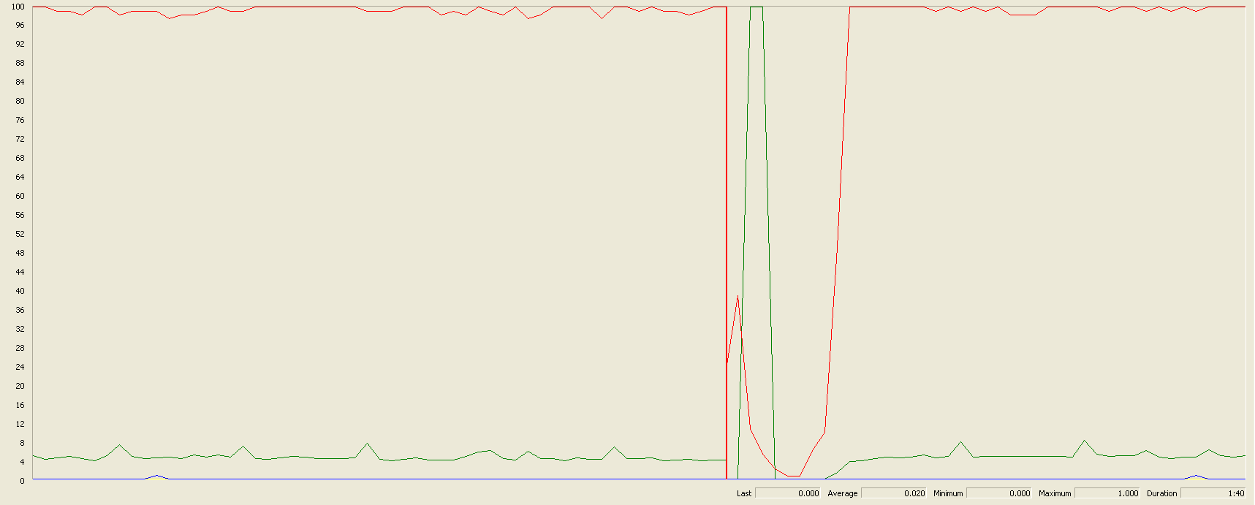

The CPU was always at its limit while the disk usage showed some peaks.

## Edit

Sequence:

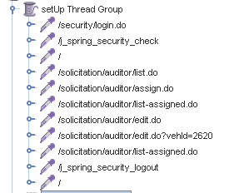

Aggregate Report:

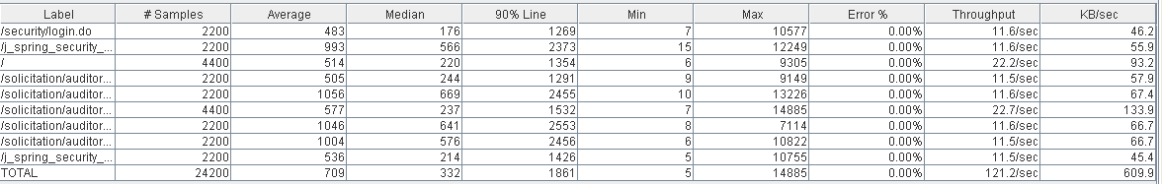

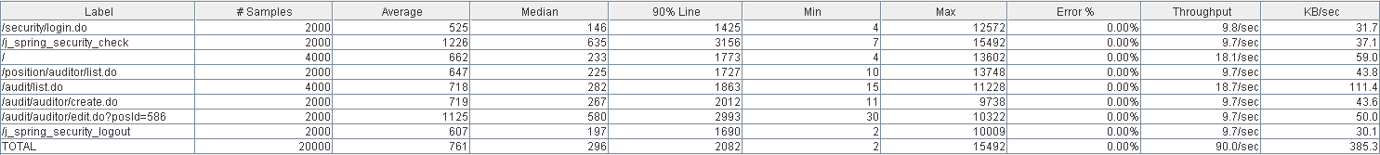

Thread properties:

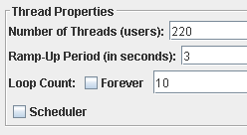

Graph Results:

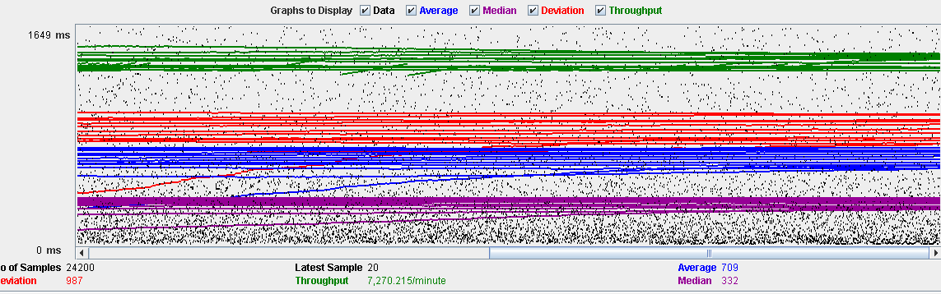

Performance Results:

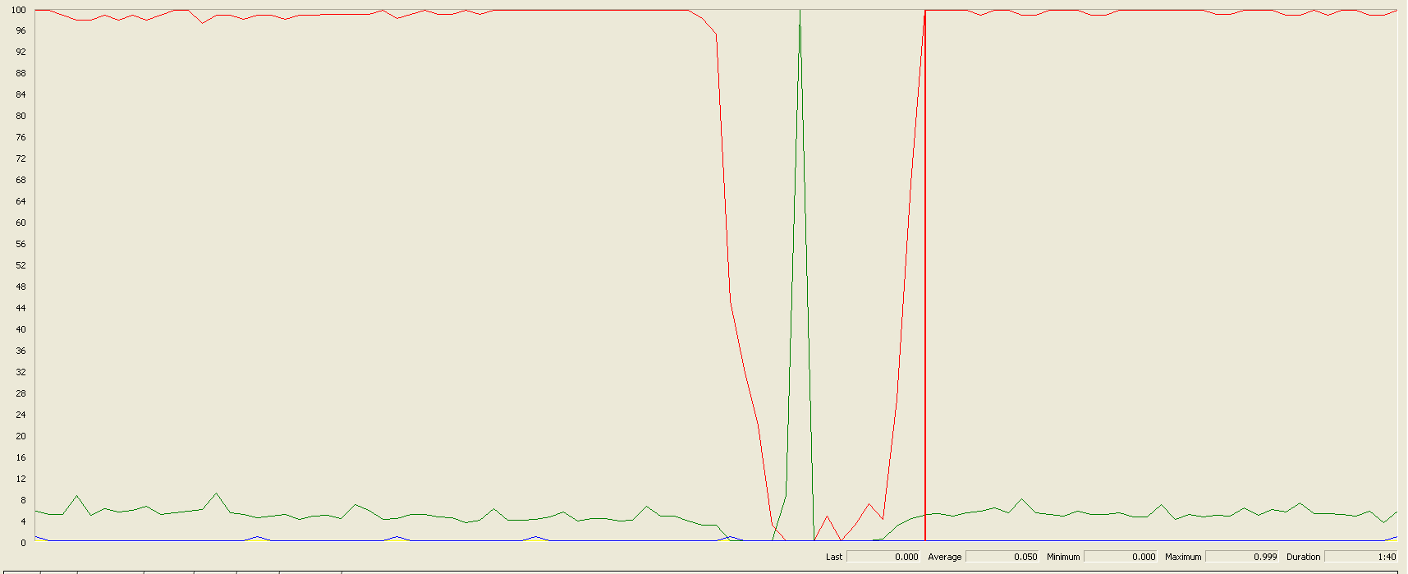

The CPU was always at its limit in various points of the execution while the disk usage showed a big peak.

## Delete

Sequence:

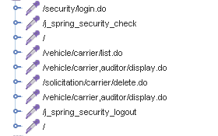

Aggregate Report:

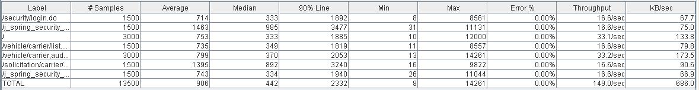

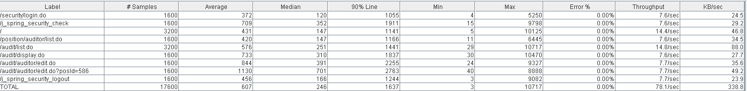

Thread properties:

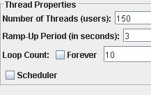

Graph Results:

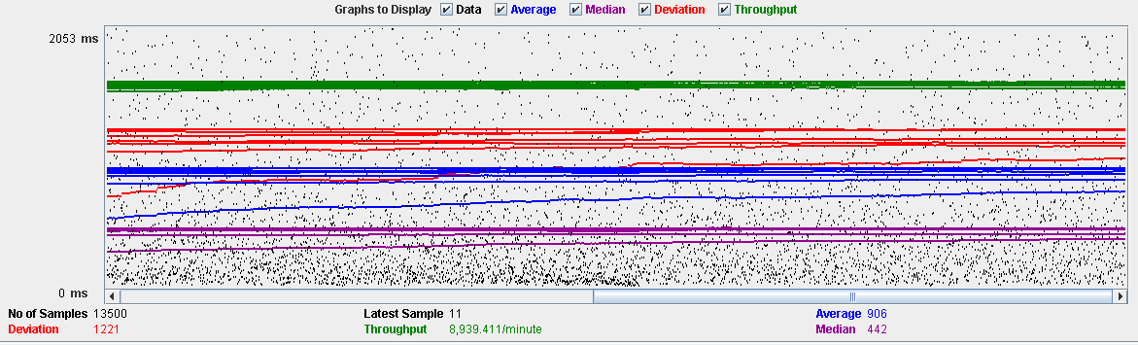

Performance Results:

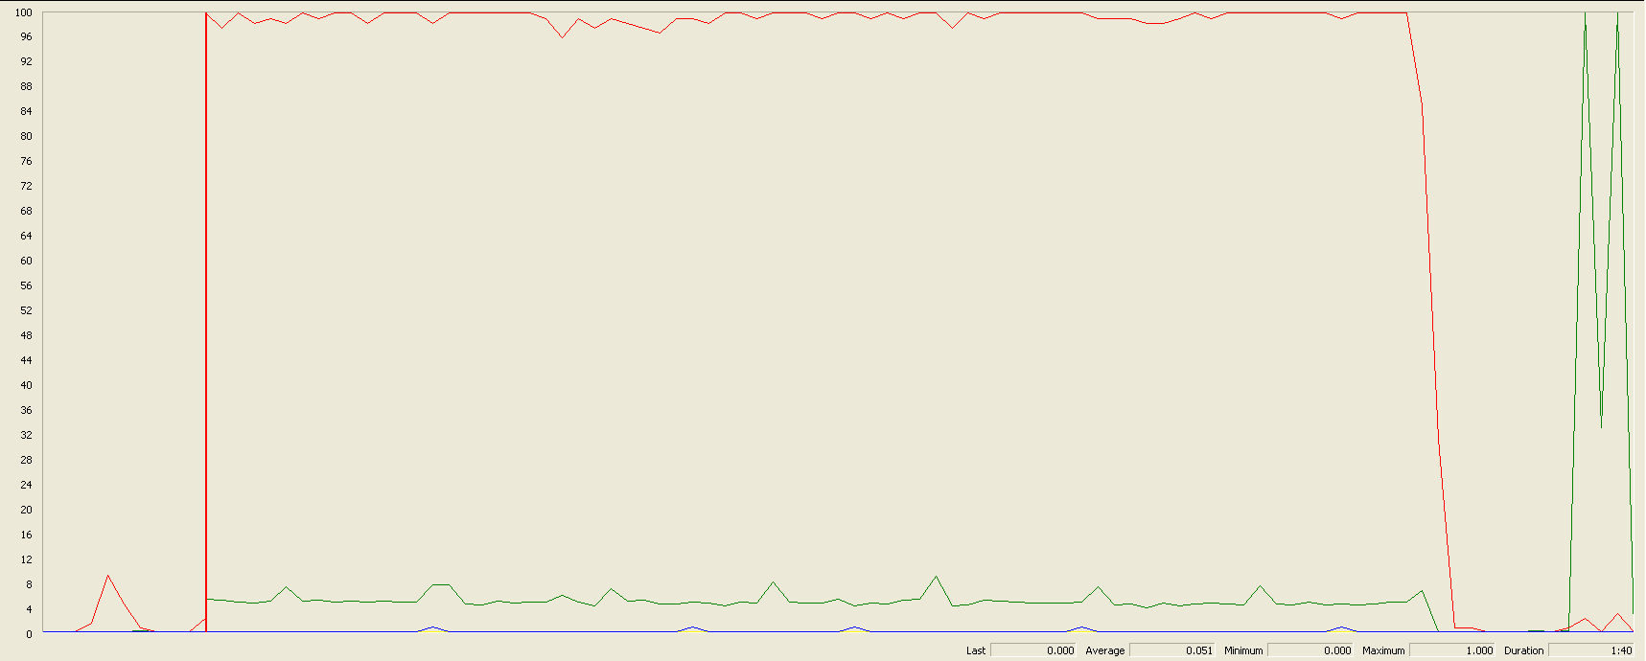

The CPU was always at its limit while the disk usage showed low peaks.

## Conclusion

The test was performed using:

CPU: i7 6700hq (2 cores in the virtual machine)

RAM: 4 GB (virtual machine)

For this use case we can say that the limitation occurs during the assign process, being the maximum of concurrent users 130.

# Sponsorship

## Create

Sequence:



Aggregate Report:

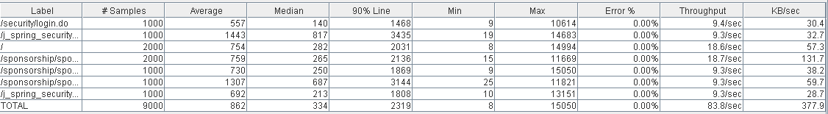

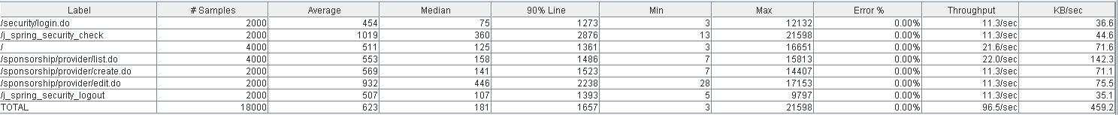

Thread properties:

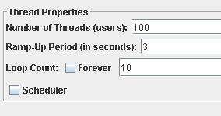

Graph Results:

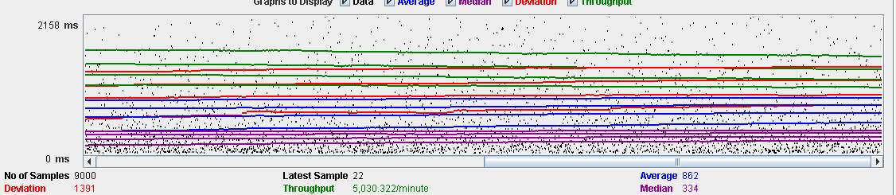

Performance Results:

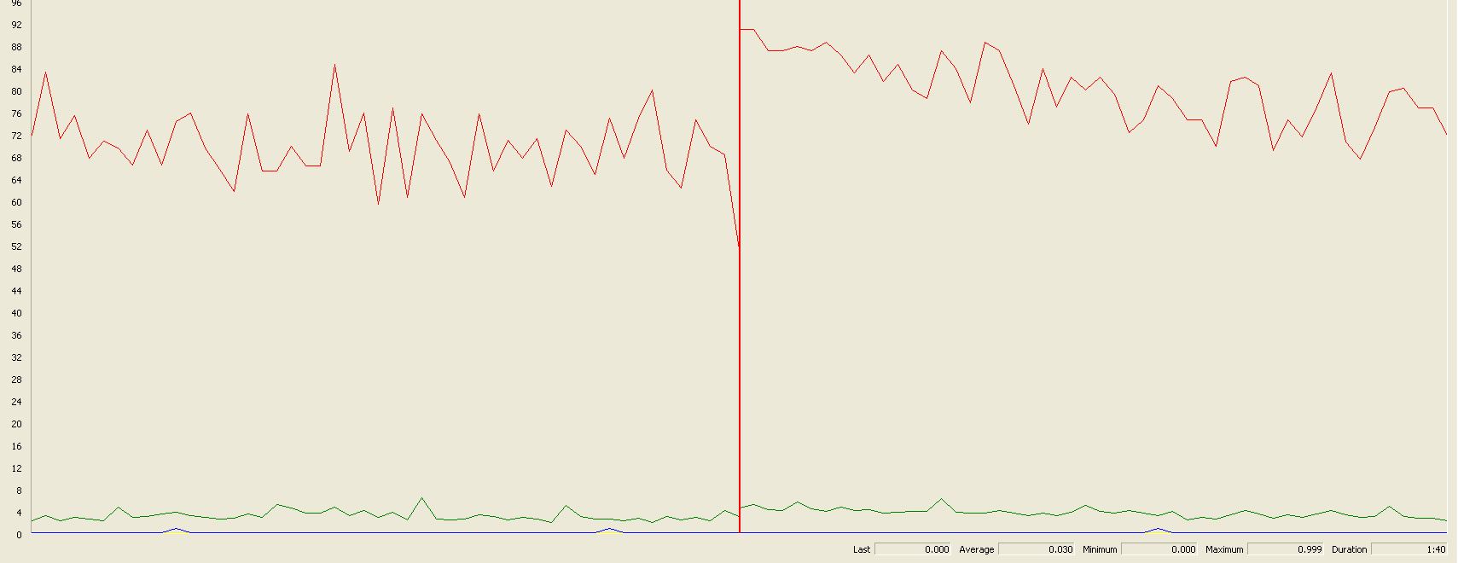

The CPU was always at its limit while the disk usage showed low peaks.

## Edit

Sequence:

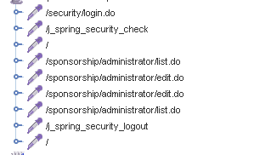

Aggregate Report:

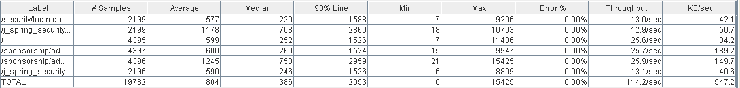



Thread properties:

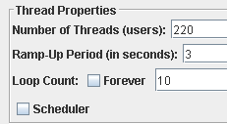

Graph Results:

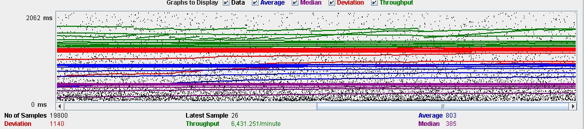

Performance Results:

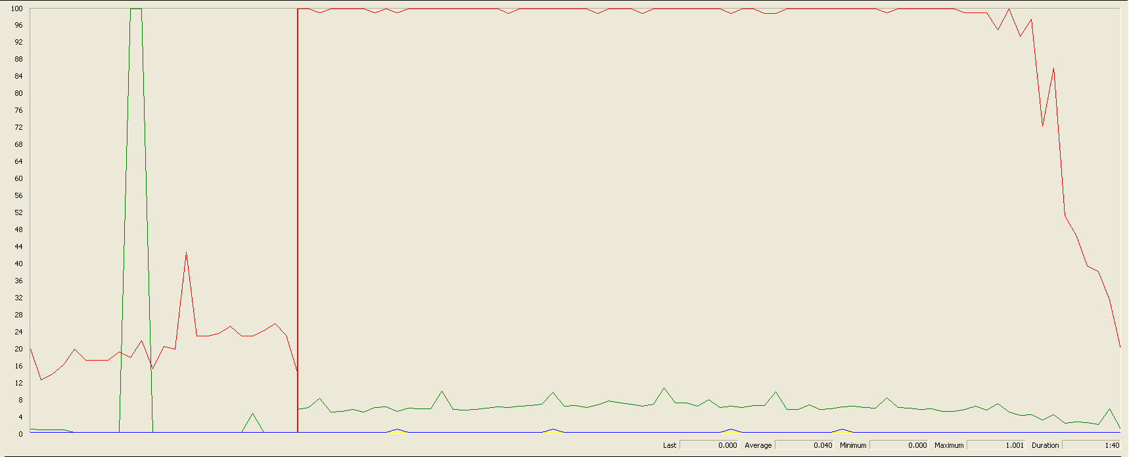

The CPU was always at its limit.

## Delete

Sequence:

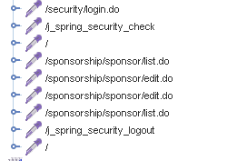

Aggregate Report:

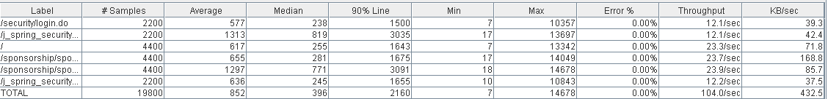



Thread properties:

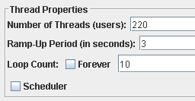

Graph Results:

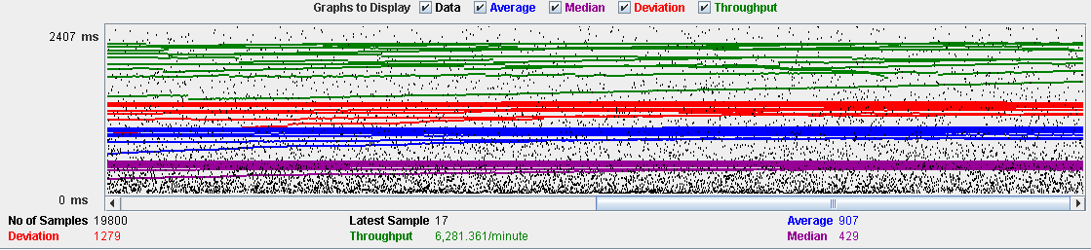

Performance Results:

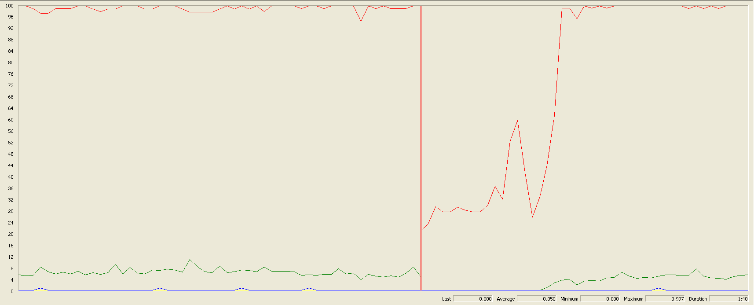

The CPU was always at its limit and had disk usage low peaks.

## Conclusion

The test was performed using:

CPU: i7 6700hq (2 cores in the virtual machine)

RAM: 4 GB (virtual machine)

For this use case we can say that the limitation occurs during the create process, being the maximum of concurrent users 100.

# Fare

## Create

Sequence:

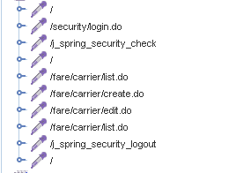

Aggregate Report:

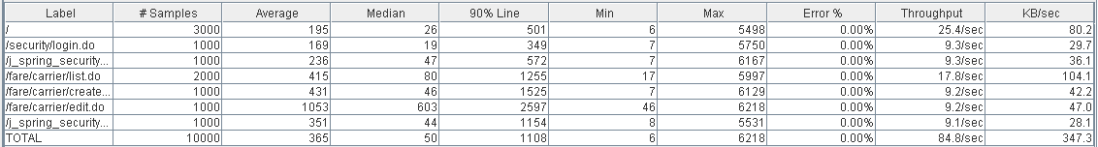

  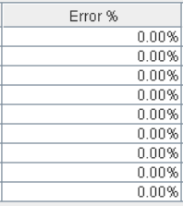

Thread properties:

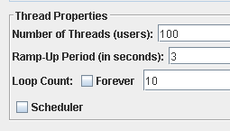

Graph Results:

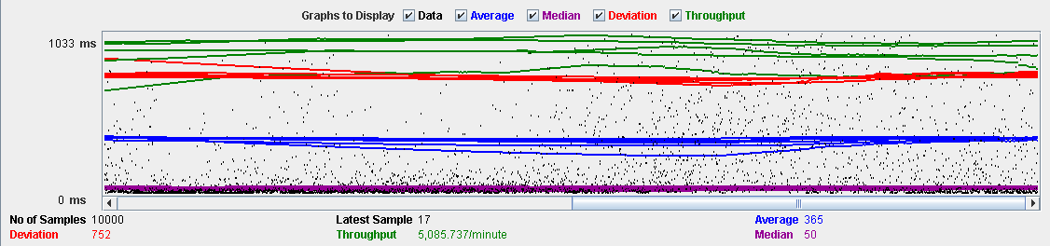

Performance Results:

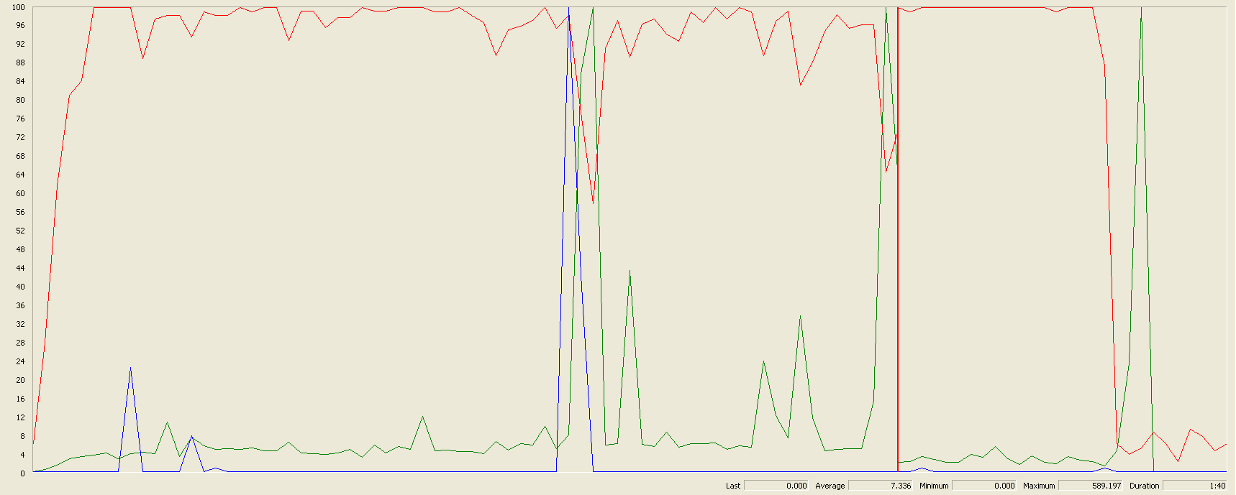

The CPU was always at its limit while the disk usage has a lot of peaks.

## Edit

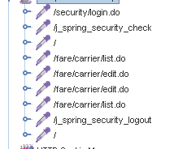Sequence:

Aggregate Report:

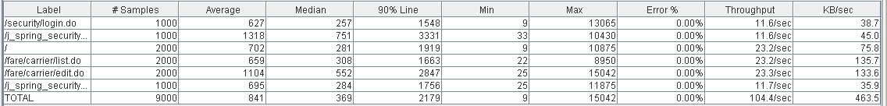

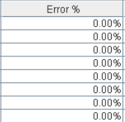

Thread properties:

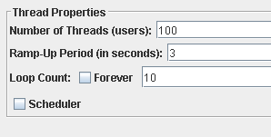

Graph Results:

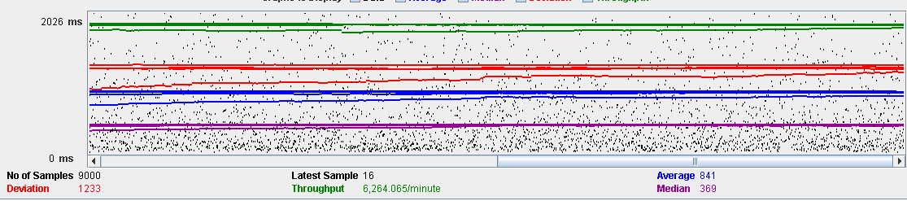

Performance Results:

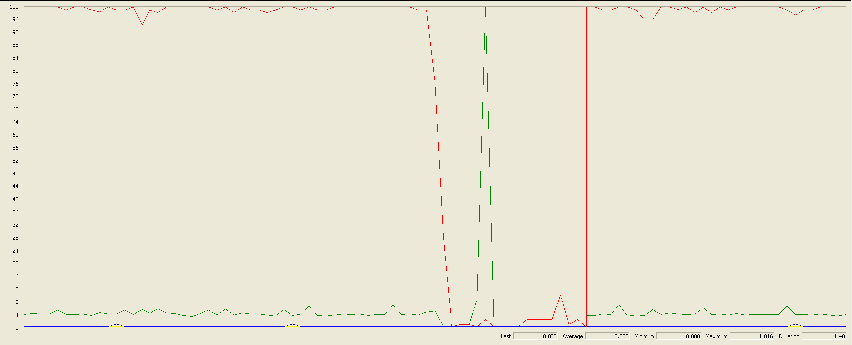

Again we can see that the CPU is always being used and disk usage had some peaks.

## Delete

Sequence:

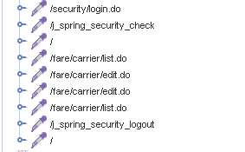

Aggregate Report:

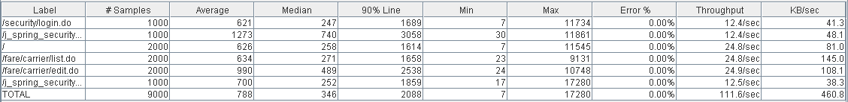

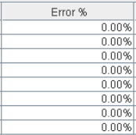

Thread properties:

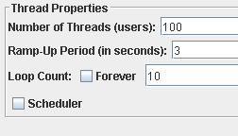

Graph Results:

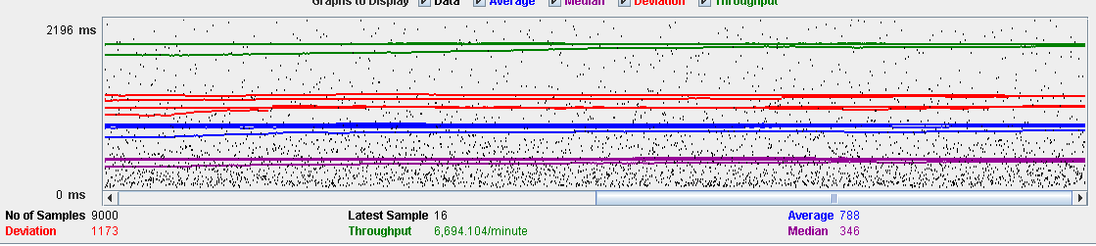

Performance Results:

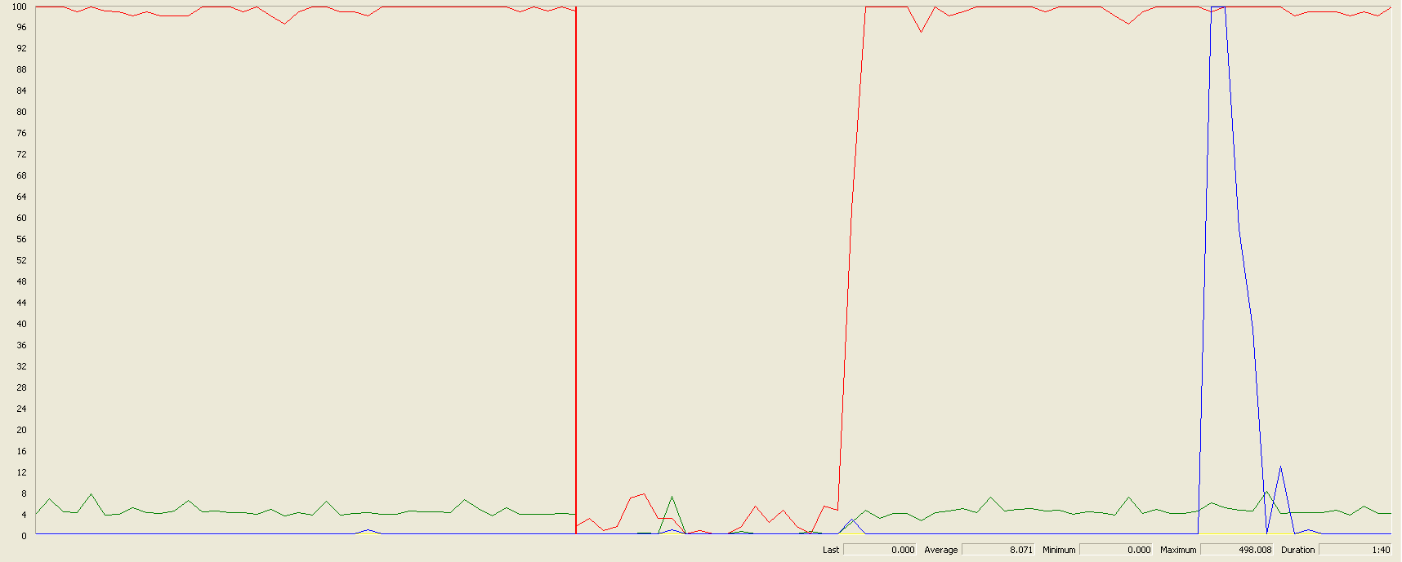

Again we can see that the CPU is always being used while the disk usage and network have different peaks.

## Conclusion

The test was performed using:

CPU: i5 7300hq (2 cores in the virtual machine)

RAM: 2 GB (virtual machine)

For this use case we can say that the limitation occurs during with all the process, being the maximum of concurrent users 100.

# Conclusion of the performance

As we can see in the tests above, the limitations of our system are in the message system, particularly in the method of execute every function available in the dashboard (30 concurrent users). We think that this may be a bit unrealistic, because in a real environment won’t be many administrators using that functions. Due that, we consider that the limit of concurrent users for our system is 54 (creating a request).